Experiment No.: 1
1.Title: Demonstration of Inline, Internal, and External JavaScript
2. Software/Tools Required: VSC,HTML,CSS
3. Theory:
Inline CSS: Inline CSS is written directly inside an HTML element using the style attribute. It is used to apply styling to a single element only. This method has the highest priority among CSS types. It is useful for quick changes but makes the code less reusable.
Internal CSS: Internal CSS is written inside the <style> tag within the <head> section of an HTML document. It is used to style multiple elements on the same webpage. This method keeps styles separate from the HTML content. It is suitable for single-page websites or small projects.
External CSS: External CSS is written in a separate .css file and linked to the HTML document using the <link> tag. It allows the same stylesheet to be used across multiple webpages. This method improves code organization and maintainability. It is the most commonly used approach in professional web development.
CODE:
<html>
<head>
<title>My Profile</title>
<style>
body{
font-family: Arial;

background:#f2f2f2;
}

.card{
width:350px;
margin:80px auto;
padding:20px;
background:white;
border-radius:10px;
text-align:center;
box-shadow:0 0 10px gray;
}

button{
padding:10px 15px;
margin:8px;
border:none;
border-radius:5px;
background:blue;
color:white;
cursor:pointer;
}

button:hover{
background:green;
}
</style>
</head>
<body>

<div class="card">
<h2>Welcome!</h2>

<p><b>Name:</b> Ayushi Ray</p>
<p><b>PRN No:</b> 24070521145</p>
<p><b>Course:</b> B.Tech CSE</p>
<p><b>College:</b> SIT Nagpur</p>

<button onclick = "console.log('Welcome Ayushi Ray'); alert('Welcome, Ayushi Ray Inline executed')"> Inline CSS </button>
<button>Internal CSS</button>

<button onclick = "console.log('Welcome Ayushi Ray'); alert('Welcome, Ayushi Ray External executed')"> External CSS</button>
</div>

<script>
console.log("Welcome to my webpage!"); alert()
</script>

</body>
</html>

4. Output:
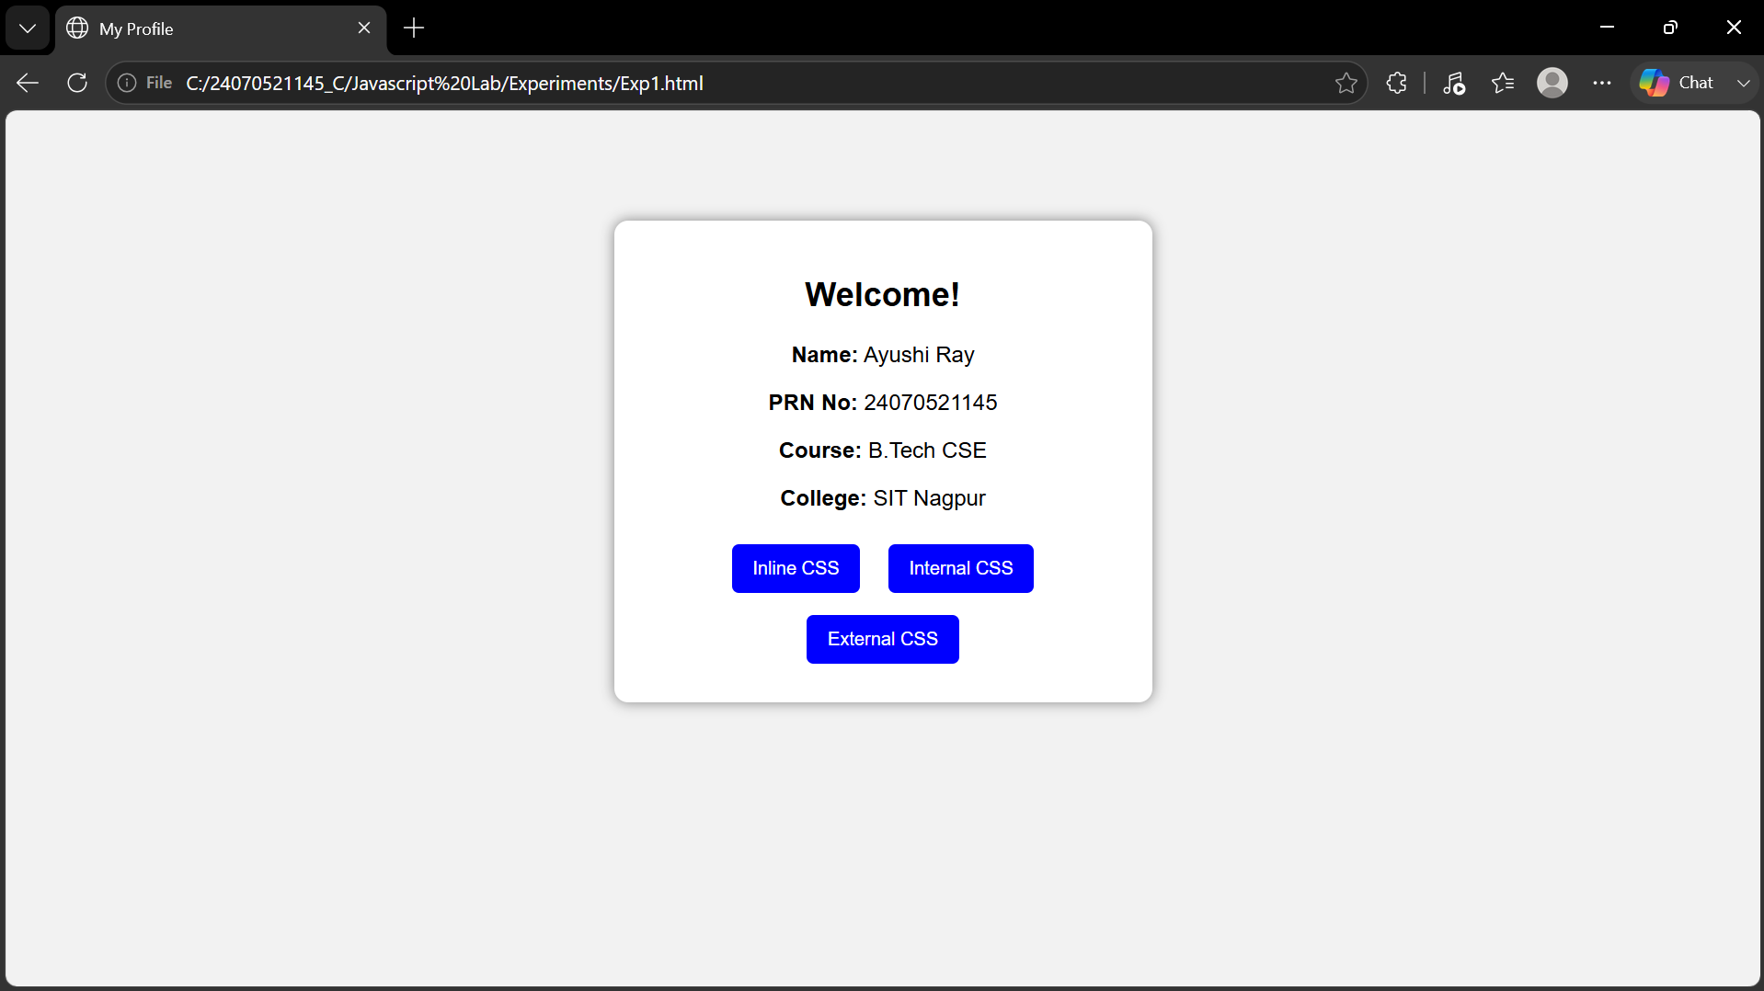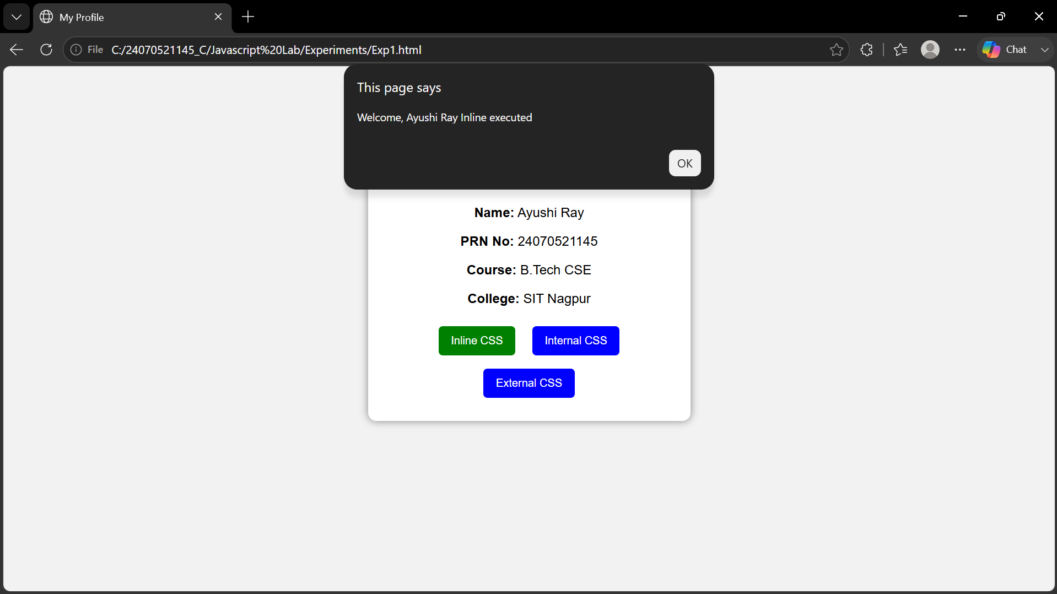

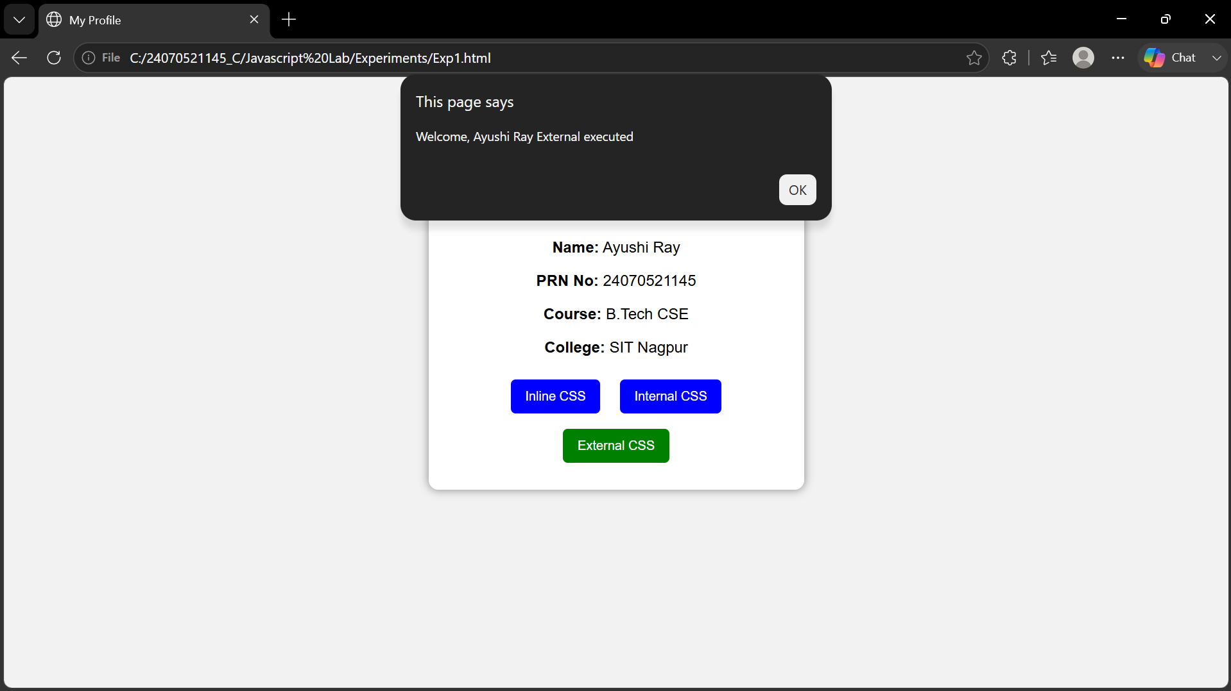
5. Result/Conclusion:
The webpage was successfully created using inline, internal, and external CSS. Different styling methods were implemented and compared, and the webpage displayed the required content with the desired formatting.

Case Study: 1
Title: Development of a College Department Webpage Using HTML, CSS, and JavaScript
Software/Tools Required: VSC, HTML, CSS, JavaScript
Case Study program code:
INDEX:
<!DOCTYPE html>
<html lang="en">
<head>
<meta charset="UTF-8">
<meta name="viewport" content="width=device-width, initial-scale=1.0">
<title>SIT Nagpur - Computer Science Department</title>

<script>
window.onload = function () {
alert("Welcome to SIT Nagpur");
};
</script>

<style>
*{
margin:0;
padding:0;

box-sizing:border-box;
font-family:Arial, Helvetica, sans-serif;
}

body{
background:#f4f7fb;
color:#333;
}

header{
background:#E10600;
color:white;
padding:25px;
text-align:center;
}

nav{
background:#B30000;;
text-align:center;
padding:12px;
}

nav a{
color:white;
text-decoration:none;

margin:0 20px;
font-weight:bold;
}

.container{
width:85%;
margin:30px auto;
}

.card{
position:relative;
background:white;
padding:40px;
border-radius:15px;
border:3px solid #D4AF37;
box-shadow:0 10px 25px rgba(0,0,0,.15);
overflow:hidden;
}

h2{
color:#E10600;
margin-bottom:15px;
}

p{

line-height:1.7;
margin-bottom:15px;
}

.btn{
display:inline-block;
padding:12px 22px;
background:#E10600;
color:white;
text-decoration:none;
border-radius:6px;
transition:.3s;
}

.btn:hover{
background:#bf0312;
}

footer{
background:#a40303;
color:white;
text-align:center;
padding:15px;
margin-top:40px;
}

.gold-flourish{
position:absolute;
color:#D4AF37;
font-size:34px;
font-weight:bold;
font-family:"Times New Roman", serif;
}

.tl{
top:10px;
left:12px;
}

.tr{
top:10px;
right:12px;
transform:rotate(90deg);
}

.bl{
bottom:10px;
left:12px;
transform:rotate(-90deg);
}

.br{
bottom:10px;
right:12px;
transform:rotate(180deg);
}

.logo{
width:120px;
height:auto;
}

</style>
</head>

<body>

<header>
<div class="header-content">

<img src="https://yt3.googleusercontent.com/HmzxLu3bNe-i-YtaNxIzXK-mdQouqAjhT-8tQENdpgyLyCy4ddXzhmhZIsLw655TjNpMdAm7mOA=s900-c-k-c0x00ffffff-no-rj" alt="SIT Logo" class="logo">

<div class="title">
<h1>Symbiosis Institute of Technology, Nagpur</h1>
<p>Department of Computer Science & Engineering</p>
</div>

</div>
</header>

<nav>
<a href="index.html">Home</a>
<a href="student.html">Student Information</a>
<a href="programme.html">Programme structure</a>

</nav>

<div class="container">
<div class="card">
<div class="corner top-left"></div>
<div class="corner top-right"></div>
<div class="corner bottom-left"></div>
<div class="corner bottom-right"></div>
<div class="gold-flourish tl">❈</div>
<div class="gold-flourish tr">❈</div>
<div class="gold-flourish bl">❈</div>
<div class="gold-flourish br">❈</div>
<h2>About the Department</h2>

<p>
The Department of Computer Science & Engineering at
SIT Nagpur is committed to delivering quality education
through modern laboratories, experienced faculty, and

industry-oriented learning practices.
</p>

<p>
The department emphasizes software development, data science,
artificial intelligence, cybersecurity, cloud computing, and
research activities that prepare students for successful careers.
</p>

</div>
</div>

<footer>
&copy; 2026 SIT Nagpur | Department of Computer Science & Engineering
</footer>

</body>
</html>
PROGRAME.HTML:
<!DOCTYPE html>
<html lang="en">
<head>
<meta charset="UTF-8">
<meta name="viewport" content="width=device-width, initial-scale=1.0">
<title>Programme Structure - SIT Nagpur</title>

<style>
*{
margin:0;
padding:0;
box-sizing:border-box;
font-family:Arial, Helvetica, sans-serif;
}

body{
background:#faf7f2;
color:#333;
}

/* Header */

header{
background:#E10600;
color:white;
text-align:center;
padding:28px;
border-bottom:6px solid #D4AF37;
}

header h1{
font-size:2.5rem;

}
header p{
margin-top:8px;
font-size:1.1rem;
}

/* Navigation */

nav{
background:#B30000;
text-align:center;
padding:14px;
}

nav a{
color:white;
text-decoration:none;
margin:0 20px;
font-weight:bold;
transition:0.3s;
}

nav a:hover{
color:#FFD700;
}

/* Container */

.container{
width:90%;
margin:40px auto;
}

.card{
background:white;
padding:30px;
border-radius:12px;
border:3px solid #D4AF37;
box-shadow:0 8px 20px rgba(0,0,0,0.12);
}

h2{
color:#E10600;
margin-bottom:10px;
}

h2::after{
content:"";
display:block;
width:110px;
height:4px;

background:#D4AF37;
margin-top:8px;
border-radius:10px;
}

p{
margin:20px 0;
line-height:1.8;
}

table{
width:100%;

border-collapse:collapse;
margin-top:25px;
}

th{
background:#E10600;
color:white;
padding:14px;
}

td{
padding:14px;
text-align:center;
border:1px solid #ddd;
}

tr:nth-child(even){
background:#f8f8f8;
}

tr:hover{
background:#fff8e6;
}

footer{
margin-top:45px;
background:#A40303;
color:white;
text-align:center;
padding:18px;
border-top:5px solid #D4AF37;
}

</style>
</head>

<body>

<header>
<h1>Symbiosis Institute of Technology, Nagpur</h1>
<p>Department of Computer Science & Engineering</p>
</header>

<nav>
<a href="index.html">Home</a>
<a href="student.html">Student Information</a>
<a href="program.html">Programme Structure</a>
</nav>

<div class="container">

<div class="card">

<h2>Programme Structure</h2>

<p>
The Bachelor of Technology (B.Tech.) in Computer Science & Engineering is designed to provide students with a strong foundation in computing principles, programming, software development, data science, artificial intelligence, networking, cybersecurity, and emerging technologies. The curriculum combines theoretical knowledge with laboratory practice, industry-oriented projects, and skill development.
</p>

<table>

<tr>
<th>Semester</th>
<th>Major Subjects</th>
<th>Credits</th>
</tr>

<tr>
<td>I</td>
<td>Programming Fundamentals, Mathematics-I, Physics, Engineering Graphics</td>
<td>22</td>
</tr>

<tr>
<td>II</td>
<td>Data Structures, Mathematics-II, Digital Electronics, Environmental Studies</td>
<td>22</td>
</tr>

<tr>
<td>III</td>
<td>Object Oriented Programming, Database Management System, Operating Systems</td>
<td>23</td>
</tr>

<tr>
<td>IV</td>
<td>Computer Networks, Design & Analysis of Algorithms, Software Engineering</td>
<td>23</td>
</tr>

<tr>
<td>V</td>
<td>Artificial Intelligence, Web Technologies, Data Science</td>
<td>22</td>
</tr>

<tr>
<td>VI</td>
<td>Cloud Computing, Cyber Security, Machine Learning</td>
<td>22</td>
</tr>

<tr>
<td>VII</td>
<td>Major Project - I, Professional Electives, Internship</td>
<td>20</td>
</tr>

<tr>

<td>VIII</td>
<td>Major Project - II, Seminar, Professional Ethics</td>
<td>18</td>
</tr>

</table>

</div>

</div>

<footer>
&copy; 2026 SIT Nagpur | Department of Computer Science & Engineering
</footer>

</body>
</html>
STUDENT.HTML:
<!DOCTYPE html>
<html lang="en">
<head>
<meta charset="UTF-8">
<meta name="viewport" content="width=device-width, initial-scale=1.0">
<title>Student Information</title>

<style>
*{
margin:0;
padding:0;
box-sizing:border-box;
font-family:Arial, Helvetica, sans-serif;
}

body{
background:#eef2f7;
}

header{
background:#c80505;
color:white;
text-align:center;
padding:20px;
background:#E10600;
color:white;
padding:25px;
text-align:center;
border-bottom:6px solid #D4AF37;
}

.container{
width:90%;
margin:35px auto;
}

table{
width:100%;
border-collapse:collapse;
background:white;
box-shadow:0 4px 10px rgba(0,0,0,0.1);
}

th{
background:#a70000;
color:white;
padding:14px;
}

td{
padding:12px;
text-align:center;
border:1px solid #ddd;
}

tr:nth-child(even){
background:#f8f8f8;
}

.back{
display:inline-block;
margin-top:20px;
text-decoration:none;
background:#c40707;
color:white;
padding:10px 20px;
border-radius:5px;
}

.back:hover{
background:#d90505;
}
</style>
</head>

<body>

<header>
<h1>Student Information</h1>
</header>

<div class="container">

<table>

<tr>
<th>PRN.</th>
<th>Name</th>
<th>Program</th>
<th>Year</th>
<th>Email</th>
</tr>

<tr>
<td>24070521145</td>
<td>Ayushi Ray</td>
<td>B.Tech CSE</td>
<td>Third Year</td>
<td>ayushi@example.com</td>
</tr>

</table>

<a href="index.html" class="back">← Back to Department Page</a>

</div>

</body>
</html>
OUTPUT SCREENSHOT:


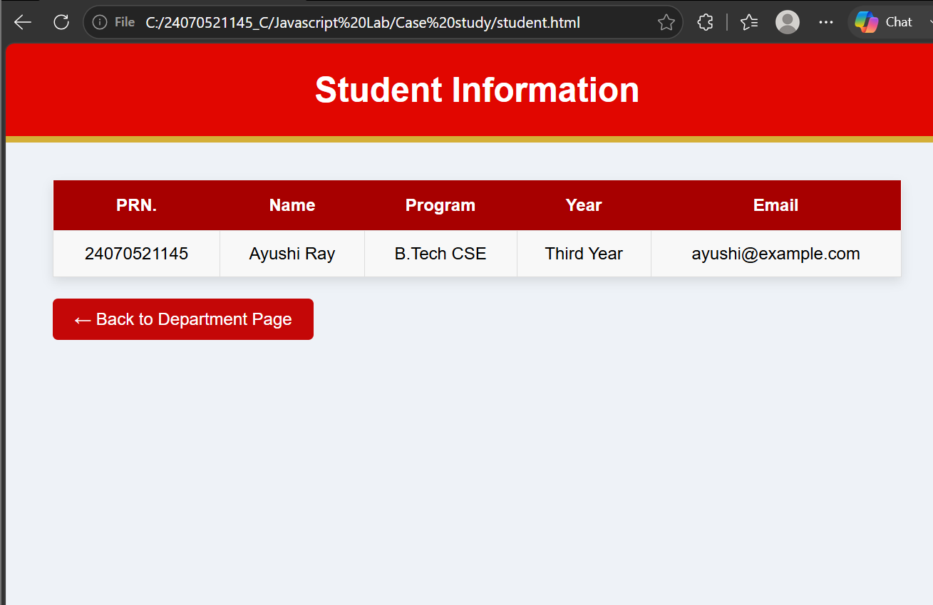

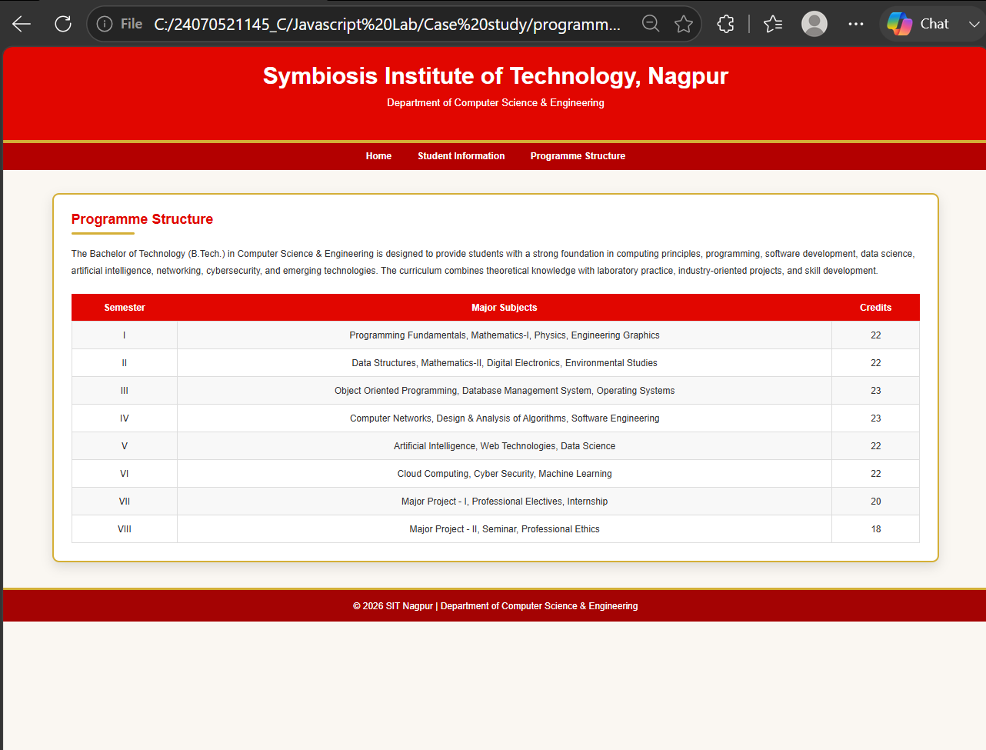

Result:
A responsive college department website was successfully developed using HTML, CSS, and JavaScript. The webpages were interconnected through hyperlinks for seamless navigation, and the JavaScript program successfully displayed the "Welcome to SIT Nagpur" alert message when the homepage was loaded. The website provided a structured, visually appealing, and interactive user interface.

Experiment No.: 2
1.Title: Use var,let,const and demonstrate basic features like template literals and destructuring; build a biling calculator with user input
2. Software/Tools Required: VSC,HTML,CSS
3. Theory:
var, let, and const are used to declare variables in JavaScript. var has function scope, while let and const have block scope, with const being used for values that should not change. Template literals use backticks (`) and ${} to embed variables in strings, making code more readable. Destructuring allows easy extraction of values from arrays or objects. A billing calculator uses these features to take user input, calculate the total bill, and display the result efficiently.
4.Codes:
INDEX.HTML:
<!DOCTYPE html>
<html lang="en">

<head>
<meta charset="UTF-8">
<meta name="viewport" content="width=device-width, initial-scale=1.0">
<title>Billing Calculator</title>
<link rel="preconnect" href="https://fonts.googleapis.com">
<link href="https://fonts.googleapis.com/css2?family=Dancing+Script:wght@600;700&family=Poppins:wght@400;500;600;700&display=swap" rel="stylesheet">

<style>
:root {

--bg-1: #b399d3;
--bg-2: #e9defa;
--ink: #2b2140;
--ink-light: #ffffff;
--plum: #4b2e83;
--plum-dark: #362161;
--gold: #b9902f;
--gold-soft: #f6ecd6;
--line: #e4dcf3;
}

* { box-sizing: border-box; }

body {
font-family: 'Poppins', sans-serif;

background-image: url("https://static.vecteezy.com/system/resources/previews/023/375/504/large_2x/minimal-workspace-on-the-desktop-of-a-home-office-with-a-notebook-a-cup-of-tea-stationery-a-bouquet-of-lilac-flowers-on-a-purple-background-flat-lay-top-view-photo.jpg");
background-size: cover;
background-position: center;
background-repeat: no-repeat;
background-attachment: fixed;

min-height: 100vh;
text-align: center;
padding: 50px 16px 70px;
color: var(--ink);
margin: 0;
}

h2 {
f

ont-family: 'Dancing Script', cursive;
font-size: 52px;
color: var(--plum-dark);
margin: 0 0 4px;
}

/* the eyebrow + flourish that sit above/below the JS-generated heading */
.eyebrow {
font-size: 12px;
letter-spacing: 4px;
text-transform: uppercase;
color: var(--plum);
font-weight: 600;
}

.flourish {
width: 90px;
height: 3px;
margin: 10px auto 30px;
background: linear-gradient(90deg, transparent, var(--gold), transparent);
border-radius: 3px;
}

.receipt {
width: 100%;
max-width: 420px;
margin: 20px auto;
background: #fff;
border-radius: 18px;
overflow: hidden;
box-shadow: 0 20px 40px -24px rgba(75, 46, 131, 0.35);

border: 1px solid var(--line);
}

table {
width: 100%;
border-collapse: collapse;
}

th {
background-color: var(--plum-dark);
color: white;
font-size: 15px;
letter-spacing: 0.5px;
padding: 14px 10px;
}

/* Grand Total row uses <th> twice, style it distinctly from the header row */
tr:last-child th {
background-color: var(--gold-soft);
color: var(--plum-dark);
font-size: 17px;
border-top: 2px solid var(--plum-dark);
}

td {
border-bottom: 1px solid var(--line);
padding: 12px 10px;
text-align: center;
font-size: 14px;
}

tr:nth-child(even) td {
background-color: #faf8ff;
}

tr:hover td {
background-color: #f3ecff;
}

h3 {
color: var(--ink-light);
font-weight: 500;
font-style: italic;
font-size: 14px;
margin-top: 22px;
}

.reload-btn {
margin-top: 26px;
font-family: 'Poppins', sans-serif;
font-weight: 600;
font-size: 14px;
padding: 12px 22px;
border-radius: 10px;
border: none;
background: var(--plum-dark);
color: #fff;
cursor: pointer;

transition: background 0.15s, transform 0.1s;
}

.reload-btn:hover { background: var(--plum); }
.reload-btn:active { transform: scale(0.97); }

.error {
color: #b3441f;
background: #fbe9e2;
display: inline-block;
padding: 10px 20px;
border-radius: 10px;
border: 1px dashed #b3441f;
font-size: 14px;
}
</style>
</head>

<body>

<div class="eyebrow">Ledger &middot; Line by line</div>
<h2>Billing Calculator</h2>
<div class="flourish"></div>

<!-- JavaScript File: uses prompt() to collect input and document.write() to print the receipt below -->
<script src="script.js"></script>

<button class="reload-btn" onclick="location.reload()">🔄 Generate New Bill</button>

</body>

</html>

SCRIPT.JS:
const GST = 0.18;

// var example
var billNumber = 1;
var customerName = prompt("Enter Customer Name:");
var productName = prompt("Enter Product Name:");

// let example
let quantity = Number(prompt("Enter Product Quantity:"));
let price = Number(prompt("Enter Price per Product:"));

// Validation

if (customerName == "" || productName == "" || quantity <= 0 || price <= 0) {
document.write(`<h3 class="error">⚠️ Please enter valid details.</h3>`);
}
else {
// Calculations

let subTotal = quantity * price;
let gstAmount = subTotal * GST;
let grandTotal = subTotal + gstAmount;

// Object

let bill = {

customerName,

productName,
quantity,
price,
subTotal,
gstAmount,
grandTotal

};

// Destructuring

const {

customerName: customer,
productName: product,
quantity: qty,
price: rate,
subTotal: subtotal,
gstAmount: gst,
grandTotal: total

} = bill;

// Template Literal

document.write(`

<h2>Billing Receipt</h2>

<div class="receipt">

<table>

<tr>
<th colspan="2">Billing Details</th>
</tr>

<tr>
<td>Bill Number</td>
<td>${billNumber}</td>
</tr>

<tr>
<td>Customer Name</td>
<td>${customer}</td>
</tr>

<tr>
<td>Product Name</td>
<td>${product}</td>
</tr>

<tr>
<td>Quantity</td>
<td>${qty}</td>
</tr>

<tr>
<td>Price Per Product</td>
<td>₹${rate.toFixed(2)}</td>
</tr>

<tr>
<td>Subtotal</td>
<td>₹${subtotal.toFixed(2)}</td>
</tr>

<tr>
<td>GST (18%)</td>
<td>₹${gst.toFixed(2)}</td>
</tr>

<tr>
<th>Grand Total</th>
<th>₹${total.toFixed(2)}</th>
</tr>

</table>

</div>

<br>

<h3>Thank You! Visit Again.</h3>

`);

billNumber++;
}

4.Outputs:
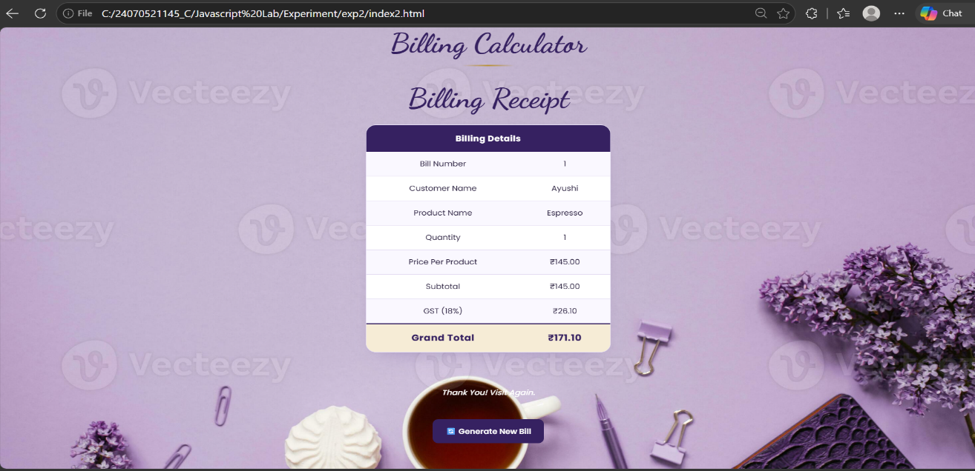
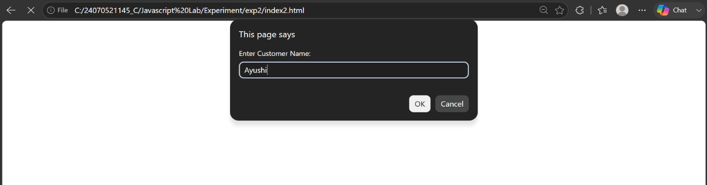

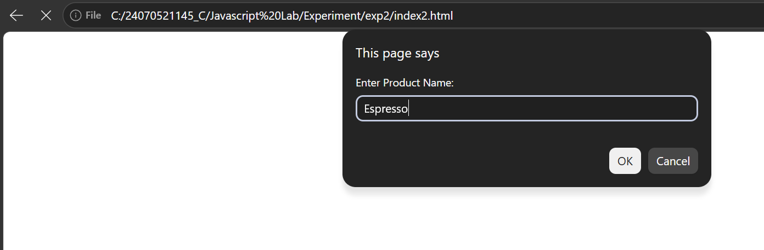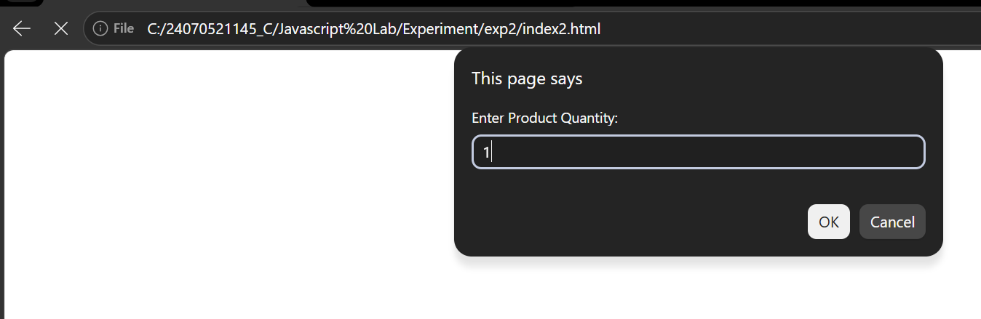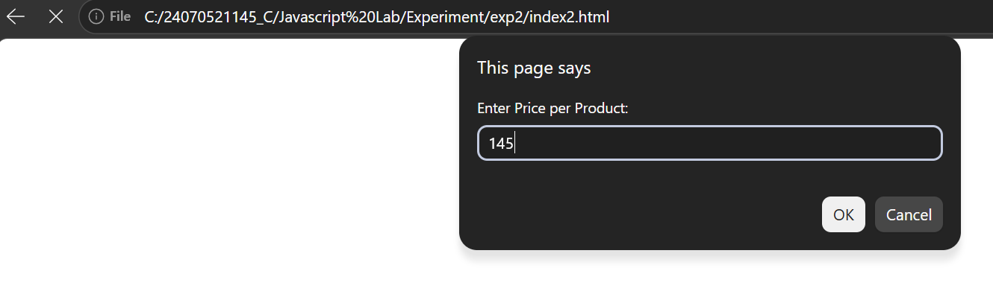
Result: The program successfully demonstrated the use of var, let, const, template literals, and destructuring. It accepted user input, calculated the total bill correctly, and displayed the billing details.

Case Study: 2
Title: Creating a billing system, using HTML VSC,CSS and Javascript based on Invoice , generating bill including tax, GST.
Software/Tools Required: VSC, HTML, CSS, JavaScript
Case Study program code:
INDEX:
<!DOCTYPE html>
<html lang="en">
<head>
<meta charset="UTF-8">
<meta name="viewport" content="width=device-width, initial-scale=1.0">
<title>WeighBill Portal — Invoice Generator</title>
<style>
:root{
--rail-bg: #1b1c1e;
--blade-bg: #24262a;
--blade-row: #2c2e33;
--blade-row-hover: #34363c;
--border: #3a3d43;
--azure-blue: #1b90d1;
--azure-blue-deep: #0f6fad;
--tile-blue: #2f7bc2;
--tile-blue-2: #1f5f9c;
--tile-teal: #1f9c8e;

--tile-purple: #7b4fa6;
--tile-orange: #d97b26;
--green-fab: #7fba00;
--text-light: #e8e9eb;
--text-dim: #9aa0a6;
--white: #ffffff;
}

*{ box-sizing: border-box; margin:0; padding:0; }

html, body{ height: 100%; }

body{
font-family: 'Segoe UI', Tahoma, Geneva, Verdana, Arial, sans-serif;
background: var(--rail-bg);
color: var(--text-light);
overflow-x: hidden;
}

.app-shell{
display:flex;
height: 100vh;
min-height: 640px;
}

/* ================= ICON RAIL ================= */
nav.icon-rail{
width: 68px;
flex-shrink:0;
background: var(--rail-bg);
display:flex;
flex-direction:column;
align-items:center;
padding: 14px 0;
border-right: 1px solid #101112;
}
.rail-btn{
width: 44px; height: 44px;
display:flex; align-items:center; justify-content:center;
color: var(--text-dim);
cursor:pointer;
border-radius: 4px;
margin-bottom: 6px;
transition: background .12s ease, color .12s ease;
position: relative;
}
.rail-btn:hover{ background: #2a2c30; color: var(--text-light); }
.rail-btn.active{ color: var(--azure-blue); }
.rail-btn.active::before{
content:"";

position:absolute; left:-14px; top:6px; bottom:6px; width:3px;
background: var(--azure-blue);
border-radius: 2px;
}
.rail-btn svg{ width:22px; height:22px; }
.rail-label{
font-size: 9px;
text-align:center;
margin-top:2px;
color: inherit;
}
.rail-btn-wrap{
display:flex; flex-direction:column; align-items:center;
margin-bottom: 10px;
cursor:pointer;
}

.rail-spacer{ flex:1; }

.fab-new{
width: 40px; height: 40px;
border-radius: 4px;
background: var(--green-fab);
color: #1b1c1e;
display:flex; align-items:center; justify-content:center;

cursor:pointer;
font-size: 26px;
font-weight: 600;
margin-bottom: 10px;
box-shadow: 0 2px 8px rgba(0,0,0,0.4);
transition: filter .12s ease, transform .1s ease;
}
.fab-new:hover{ filter: brightness(1.1); }
.fab-new:active{ transform: scale(0.95); }

/* ================= BLADE ================= */
aside.blade{
width: 380px;
flex-shrink:0;
background: var(--blade-bg);
border-right: 1px solid var(--border);
display:flex;
flex-direction:column;
transition: margin-left .25s ease;
}
aside.blade.closed{ margin-left: -380px; }

.blade-head{
padding: 18px 20px 12px;
border-bottom: 1px solid var(--border);

}
.blade-head-top{
display:flex;
align-items:center;
justify-content:space-between;
}
.blade-head-top h1{
font-size: 1.15rem;
font-weight: 400;
}
.blade-close{
cursor:pointer;
color: var(--text-dim);
font-size: 1.1rem;
padding: 4px 8px;
}
.blade-close:hover{ color: var(--text-light); }

.blade-sub{
display:flex;
justify-content:flex-end;
align-items:center;
gap:4px;
color: var(--azure-blue);
font-size: 0.82rem;

margin-top: 6px;
cursor:pointer;
user-select:none;
}
.blade-sub svg{ width:14px; height:14px; }

.blade-list{
flex:1;
overflow-y:auto;
padding: 8px 0;
}

.blade-item{
border-bottom: 1px solid #2a2c30;
}
.blade-item-head{
display:flex;
align-items:flex-start;
gap: 12px;
padding: 14px 20px;
cursor:pointer;
transition: background .12s ease;
}
.blade-item-head:hover{ background: var(--blade-row-hover); }
.blade-item.open .blade-item-head{ background: var(--blade-row); }

.

icon-box{
width: 38px; height:38px;
border-radius: 3px;
flex-shrink:0;
display:flex; align-items:center; justify-content:center;
color: var(--white);
}
.icon-box svg{ width:20px; height:20px; }
.icon-box.blue{ background: var(--tile-blue); }
.icon-box.orange{ background: var(--tile-orange); }
.icon-box.purple{ background: var(--tile-purple); }
.icon-box.teal{ background: var(--tile-teal); }

.blade-item-text{ flex:1; min-width:0; }
.blade-item-text .t{ font-size: 0.95rem; font-weight: 500; color: var(--text-light); }
.blade-item-text .d{ font-size: 0.78rem; color: var(--text-dim); margin-top: 2px; line-height:1.4; }

.chevron{
color: var(--text-dim);
transition: transform .2s ease;
margin-top: 8px;
}
.blade-item.open .chevron{ transform: rotate(90deg); }

.blade-item-body{
max-height:0;

overflow:hidden;
transition: max-height .25s ease;
background: #202225;
}
.blade-item.open .blade-item-body{ max-height: 600px; }

.field-grid{
padding: 16px 20px 20px;
display:grid;
grid-template-columns: 1fr 1fr;
gap: 12px 12px;
}
.field-grid .full{ grid-column: 1/-1; }

.field-grid label{
display:block;
font-size: 0.72rem;
color: var(--text-dim);
margin-bottom: 5px;
}
.field-grid input[type="text"],
.field-grid input[type="tel"],
.field-grid input[type="number"],
.field-grid select{
width:100%;

background: #17181a;
border: 1px solid var(--border);
color: var(--text-light);
padding: 8px 10px;
border-radius: 2px;
font-size: 0.85rem;
font-family: inherit;
}
.field-grid input:focus, .field-grid select:focus{
outline:none;
border-color: var(--azure-blue);
}

.yn-row, .pay-row{
display:flex; gap:8px;
}
.yn-btn, .pay-btn{
flex:1;
text-align:center;
padding: 7px 4px;
border: 1px solid var(--border);
border-radius: 2px;
font-size: 0.78rem;
cursor:pointer;
color: var(--text-dim);

background: #17181a;
}
.yn-btn.active, .pay-btn.active{
background: var(--azure-blue);
border-color: var(--azure-blue);
color: var(--white);
}

.blade-footer{
padding: 14px 20px;
border-top: 1px solid var(--border);
}
.btn-generate{
width:100%;
background: var(--azure-blue);
color: var(--white);
border:none;
padding: 11px 0;
font-size: 0.9rem;
border-radius: 2px;
cursor:pointer;
font-weight: 500;
}
.btn-generate:hover{ background: var(--azure-blue-deep); }

/* ================= DASHBOARD ================= */
main.dashboard{
flex:1;
position:relative;
overflow:auto;
background:
radial-gradient(circle at 20% 30%, rgba(255,255,255,0.05), transparent 45%),
linear-gradient(160deg, #1e6fa8 0%, #124a78 55%, #0d3a60 100%);
padding: 26px;
}

.dash-grid{
display:grid;
grid-template-columns: 300px repeat(2, 150px);
grid-auto-rows: 145px;
gap: 12px;
max-width: 900px;
}

.tile{
border-radius: 2px;
padding: 14px;
display:flex;
flex-direction:column;
justify-content:space-between;

color: var(--white);
position:relative;
overflow:hidden;
box-shadow: 0 2px 10px rgba(0,0,0,0.25);
}
.tile .t-label{
font-size: 0.72rem;
text-transform: uppercase;
letter-spacing: 0.05em;
opacity: 0.85;
}
.tile .t-value{
font-size: 1.5rem;
font-weight: 300;
}
.tile .t-icon{
position:absolute;
right: 12px; top: 12px;
opacity: 0.9;
}
.tile .t-icon svg{ width:26px; height:26px; }

.tile-hero{
grid-column: span 1;
grid-row: span 2;

background: linear-gradient(135deg, #2481c2, #145d97);
justify-content:flex-end;
}
.tile-hero .t-label{ font-size: 0.78rem; }
.tile-hero .t-value{ font-size: 2.3rem; font-weight: 200; margin: 4px 0; }
.tile-hero .t-sub{ font-size: 0.75rem; opacity: 0.85; }

.tile-blue{ background: var(--tile-blue); }
.tile-blue2{ background: var(--tile-blue-2); }
.tile-teal{ background: var(--tile-teal); }
.tile-purple{ background: var(--tile-purple); }
.tile-orange{ background: var(--tile-orange); }
.tile-dark{ background: #1a1b1e; }

.tile-member-badge{
display:inline-block;
background: var(--green-fab);
color:#1b1c1e;
font-size: 0.62rem;
text-transform:uppercase;
padding: 2px 6px;
border-radius: 2px;
margin-top: 4px;
font-weight:600;
}

.

tile-wide{
grid-column: span 2;
}

.dash-caption{
color: rgba(255,255,255,0.9);
font-size: 0.85rem;
margin-bottom: 14px;
}
.dash-caption strong{ font-weight:600; }

@media (max-width: 760px){
aside.blade{ position:fixed; z-index:20; height:100vh; }
.dash-grid{ grid-template-columns: 1fr 1fr; }
.tile-hero{ grid-column: 1/-1; grid-row: span 1; }
}
</style>
</head>
<body>

<div class="app-shell">

<!-- ============ ICON RAIL ============ -->
<nav class="icon-rail">

<div class="rail-btn-wrap">
<div class="rail-btn active" title="Home">
<svg viewBox="0 0 24 24" fill="none" stroke="currentColor" stroke-width="1.6"><path d="M3 11.5 12 4l9 7.5"/><path d="M5 10v9h14v-9"/></svg>
</div>
</div>
<div class="rail-btn-wrap">
<div class="rail-btn" title="Notifications">
<svg viewBox="0 0 24 24" fill="none" stroke="currentColor" stroke-width="1.6"><path d="M18 8a6 6 0 1 0-12 0c0 7-3 9-3 9h18s-3-2-3-9"/><path d="M13.7 21a2 2 0 0 1-3.4 0"/></svg>
</div>
</div>
<div class="rail-btn-wrap">
<div class="rail-btn" title="Browse">
<svg viewBox="0 0 24 24" fill="none" stroke="currentColor" stroke-width="1.6"><rect x="3" y="4" width="18" height="16" rx="1"/><path d="M3 9h18"/></svg>
</div>
</div>
<div class="rail-btn-wrap">
<div class="rail-btn" title="Journeys">
<svg viewBox="0 0 24 24" fill="none" stroke="currentColor" stroke-width="1.6"><path d="M4 20 10 4l4 10 3-6 3 12"/></svg>
</div>
</div>
<div class="rail-btn-wrap">

<div class="rail-btn" title="Billing">
<svg viewBox="0 0 24 24" fill="none" stroke="currentColor" stroke-width="1.6"><rect x="3" y="5" width="18" height="14" rx="1"/><path d="M3 10h18"/></svg>
</div>
</div>
<div class="rail-spacer"></div>
<div class="fab-new" id="fabNew" title="New invoice">+</div>
</nav>

<!-- ============ BLADE ============ -->
<aside class="blade" id="blade">
<div class="blade-head">
<div class="blade-head-top">
<h1>New Invoice</h1>
<div class="blade-close" id="bladeClose">&times;</div>
</div>
<div class="blade-sub" id="resetLink">
Reset form
<svg viewBox="0 0 24 24" fill="none" stroke="currentColor" stroke-width="2"><path d="M5 12h14M13 6l6 6-6 6"/></svg>
</div>
</div>

<form id="billForm">

<div class="blade-list">

<!-- Customer & Invoice -->
<div class="blade-item open" data-item="customer">
<div class="blade-item-head">
<div class="icon-box blue">
<svg viewBox="0 0 24 24" fill="none" stroke="currentColor" stroke-width="1.8"><circle cx="12" cy="8" r="3.2"/><path d="M5 20c1.5-4 4-6 7-6s5.5 2 7 6"/></svg>
</div>
<div class="blade-item-text">
<div class="t">Customer &amp; Invoice</div>
<div class="d">Name, mobile number and invoice ID</div>
</div>
<div class="chevron">&rsaquo;</div>
</div>
<div class="blade-item-body">
<div class="field-grid">
<div class="full">
<label for="custName">Customer Name</label>
<input type="text" id="custName" placeholder="e.g. Rohan Sharma" required>
</div>
<div>
<label for="mobile">Mobile Number</label>
<input type="tel" id="mobile" placeholder="98XXXXXXXX" maxlength="10" required>

</div>
<div>
<label for="invoiceNo">Invoice Number</label>
<input type="text" id="invoiceNo" placeholder="INV-0001" required>
</div>
</div>
</div>
</div>

<!-- Item -->
<div class="blade-item" data-item="item">
<div class="blade-item-head">
<div class="icon-box orange">
<svg viewBox="0 0 24 24" fill="none" stroke="currentColor" stroke-width="1.8"><path d="M3 7l9-4 9 4-9 4-9-4Z"/><path d="M3 7v10l9 4 9-4V7"/></svg>
</div>
<div class="blade-item-text">
<div class="t">Item Details</div>
<div class="d">Product, quantity in kg, and rate</div>
</div>
<div class="chevron">&rsaquo;</div>
</div>
<div class="blade-item-body">
<div class="field-grid">
<div class="full">
<label for="productName">Product Name</label>

<input type="text" id="productName" placeholder="e.g. Basmati Rice" required>
</div>
<div>
<label for="qty">Quantity (kg)</label>
<input type="number" id="qty" min="0" step="0.01" placeholder="0.00" required>
</div>
<div>
<label for="rate">Rate per kg (₹)</label>
<input type="number" id="rate" min="0" step="0.01" placeholder="0.00" required>
</div>
</div>
</div>
</div>

<!-- Charges & Tax -->
<div class="blade-item" data-item="charges">
<div class="blade-item-head">
<div class="icon-box purple">
<svg viewBox="0 0 24 24" fill="none" stroke="currentColor" stroke-width="1.8"><path d="M19 5 5 19"/><circle cx="7" cy="7" r="2"/><circle cx="17" cy="17" r="2"/></svg>
</div>
<div class="blade-item-text">
<div class="t">Charges &amp; Tax</div>
<div class="d">Discount, GST and packing charges</div>

</div>
<div class="chevron">&rsaquo;</div>
</div>
<div class="blade-item-body">
<div class="field-grid">
<div>
<label for="discount">Discount (%)</label>
<input type="number" id="discount" min="0" max="100" step="0.1" value="0">
</div>
<div>
<label for="gst">GST (%)</label>
<input type="number" id="gst" min="0" max="100" step="0.1" value="5">
</div>
<div class="full">
<label for="packing">Packing Charges (₹)</label>
<input type="number" id="packing" min="0" step="0.01" value="0">
</div>
</div>
</div>
</div>

<!-- Payment & Membership -->
<div class="blade-item" data-item="payment">
<div class="blade-item-head">
<div class="icon-box teal">

<svg viewBox="0 0 24 24" fill="none" stroke="currentColor" stroke-width="1.8"><rect x="3" y="5" width="18" height="14" rx="1.5"/><path d="M3 10h18"/></svg>
</div>
<div class="blade-item-text">
<div class="t">Payment &amp; Membership</div>
<div class="d">Payment mode and membership status</div>
</div>
<div class="chevron">&rsaquo;</div>
</div>
<div class="blade-item-body">
<div class="field-grid">
<div class="full">
<label>Payment Mode</label>
<div class="pay-row" id="payRow">
<div class="pay-btn active" data-val="Cash">Cash</div>
<div class="pay-btn" data-val="Card">Card</div>
<div class="pay-btn" data-val="UPI">UPI</div>
</div>
</div>
<div class="full">
<label>Membership</label>
<div class="yn-row" id="memberRow2">
<div class="yn-btn active" data-val="N">No</div>
<div class="yn-btn" data-val="Y">Yes (2% extra off)</div>
</div>
</div>

</div>
</div>
</div>

</div>

<div class="blade-footer">
<button type="submit" class="btn-generate">Generate Bill</button>
</div>
</form>
</aside>

<!-- ============ DASHBOARD ============ -->
<main class="dashboard">
<div class="dash-caption">Invoice preview for <strong id="capName">—</strong> · <span id="capInvoice">—</span></div>

<div class="dash-grid">

<div class="tile tile-hero">
<div class="t-icon"><svg viewBox="0 0 24 24" fill="none" stroke="#fff" stroke-width="1.6"><path d="M4 20V10l8-6 8 6v10"/><path d="M9 20v-6h6v6"/></svg></div>
<div>
<div class="t-label">Total Amount</div>
<div class="t-value" id="tileTotal">₹0.00</div>

<div class="t-sub" id="tilePayMode">Payment mode: Cash <span id="tileMemberBadge"></span></div>
</div>
</div>

<div class="tile tile-blue">
<div class="t-label">Subtotal</div>
<div class="t-value" id="tileSubtotal">₹0.00</div>
</div>

<div class="tile tile-purple">
<div class="t-label">Discount</div>
<div class="t-value" id="tileDiscount">− ₹0.00</div>
</div>

<div class="tile tile-teal">
<div class="t-label">GST</div>
<div class="t-value" id="tileGst">+ ₹0.00</div>
</div>

<div class="tile tile-orange">
<div class="t-label">Packing</div>
<div class="t-value" id="tilePacking">+ ₹0.00</div>
</div>

<div class="tile tile-blue2 tile-wide">

<div class="t-label">Item</div>
<div class="t-value" style="font-size:1.15rem;" id="tileItem">—</div>
</div>

</div>
</main>

</div>

<script>
(function(){
const blade = document.getElementById('blade');
const fabNew = document.getElementById('fabNew');
const bladeClose = document.getElementById('bladeClose');
const resetLink = document.getElementById('resetLink');
const form = document.getElementById('billForm');

fabNew.addEventListener('click', () => blade.classList.toggle('closed'));
bladeClose.addEventListener('click', () => blade.classList.add('closed'));

// Accordion behaviour
document.querySelectorAll('.blade-item-head').forEach(head => {
head.addEventListener('click', () => {
const item = head.parentElement;
const wasOpen = item.classList.contains('open');

document.querySelectorAll('.blade-item').forEach(i => i.classList.remove('open'));
if(!wasOpen) item.classList.add('open');
});
});

// Payment mode toggle
let payMode = 'Cash';
document.querySelectorAll('#payRow .pay-btn').forEach(btn => {
btn.addEventListener('click', (e) => {
e.stopPropagation();
document.querySelectorAll('#payRow .pay-btn').forEach(b => b.classList.remove('active'));
btn.classList.add('active');
payMode = btn.dataset.val;
calculateAndRender();
});
});

// Membership toggle
let membership = 'N';
document.querySelectorAll('#memberRow2 .yn-btn').forEach(btn => {
btn.addEventListener('click', (e) => {
e.stopPropagation();
document.querySelectorAll('#memberRow2 .yn-btn').forEach(b => b.classList.remove('active'));

btn.classList.add('active');
membership = btn.dataset.val;
calculateAndRender();
});
});

function fmt(n){
return '₹' + n.toLocaleString('en-IN', {minimumFractionDigits:2, maximumFractionDigits:2});
}

function calculateAndRender(e){
if(e) e.preventDefault();

const custName = document.getElementById('custName').value.trim() || '—';
const invoiceNo = document.getElementById('invoiceNo').value.trim() || '—';
const productName = document.getElementById('productName').value.trim() || '—';
const qty = parseFloat(document.getElementById('qty').value) || 0;
const rate = parseFloat(document.getElementById('rate').value) || 0;
const discountPct = parseFloat(document.getElementById('discount').value) || 0;
const gstPct = parseFloat(document.getElementById('gst').value) || 0;
const packing = parseFloat(document.getElementById('packing').value) || 0;

const subtotal = qty * rate;
const discountAmt = subtotal * (discountPct / 100);
let afterDiscount = subtotal - discountAmt;

let memberAmt = 0;
if (membership === 'Y'){
memberAmt = afterDiscount * 0.02;
afterDiscount -= memberAmt;
}

const gstAmt = afterDiscount * (gstPct / 100);
const total = afterDiscount + gstAmt + packing;

document.getElementById('capName').textContent = custName;
document.getElementById('capInvoice').textContent = invoiceNo;

document.getElementById('tileTotal').textContent = fmt(total);
document.getElementById('tilePayMode').innerHTML = 'Payment mode: ' + payMode +
(membership === 'Y' ? ' <span class="tile-member-badge">Member</span>' : '');
document.getElementById('tileSubtotal').textContent = fmt(subtotal);
document.getElementById('tileDiscount').textContent = '− ' + fmt(discountAmt + memberAmt);
document.getElementById('tileGst').textContent = '+ ' + fmt(gstAmt);
document.getElementById('tilePacking').textContent = '+ ' + fmt(packing);
document.getElementById('tileItem').textContent = productName + ' · ' + qty.toFixed(2) + ' kg × ' + fmt(rate);
}

form.addEventListener('submit', calculateAndRender);
form.addEventListener('input', calculateAndRender);

calculateAndRender();
})();
</script>

</body>
</html>
OUTPUT SCREENSHOT:
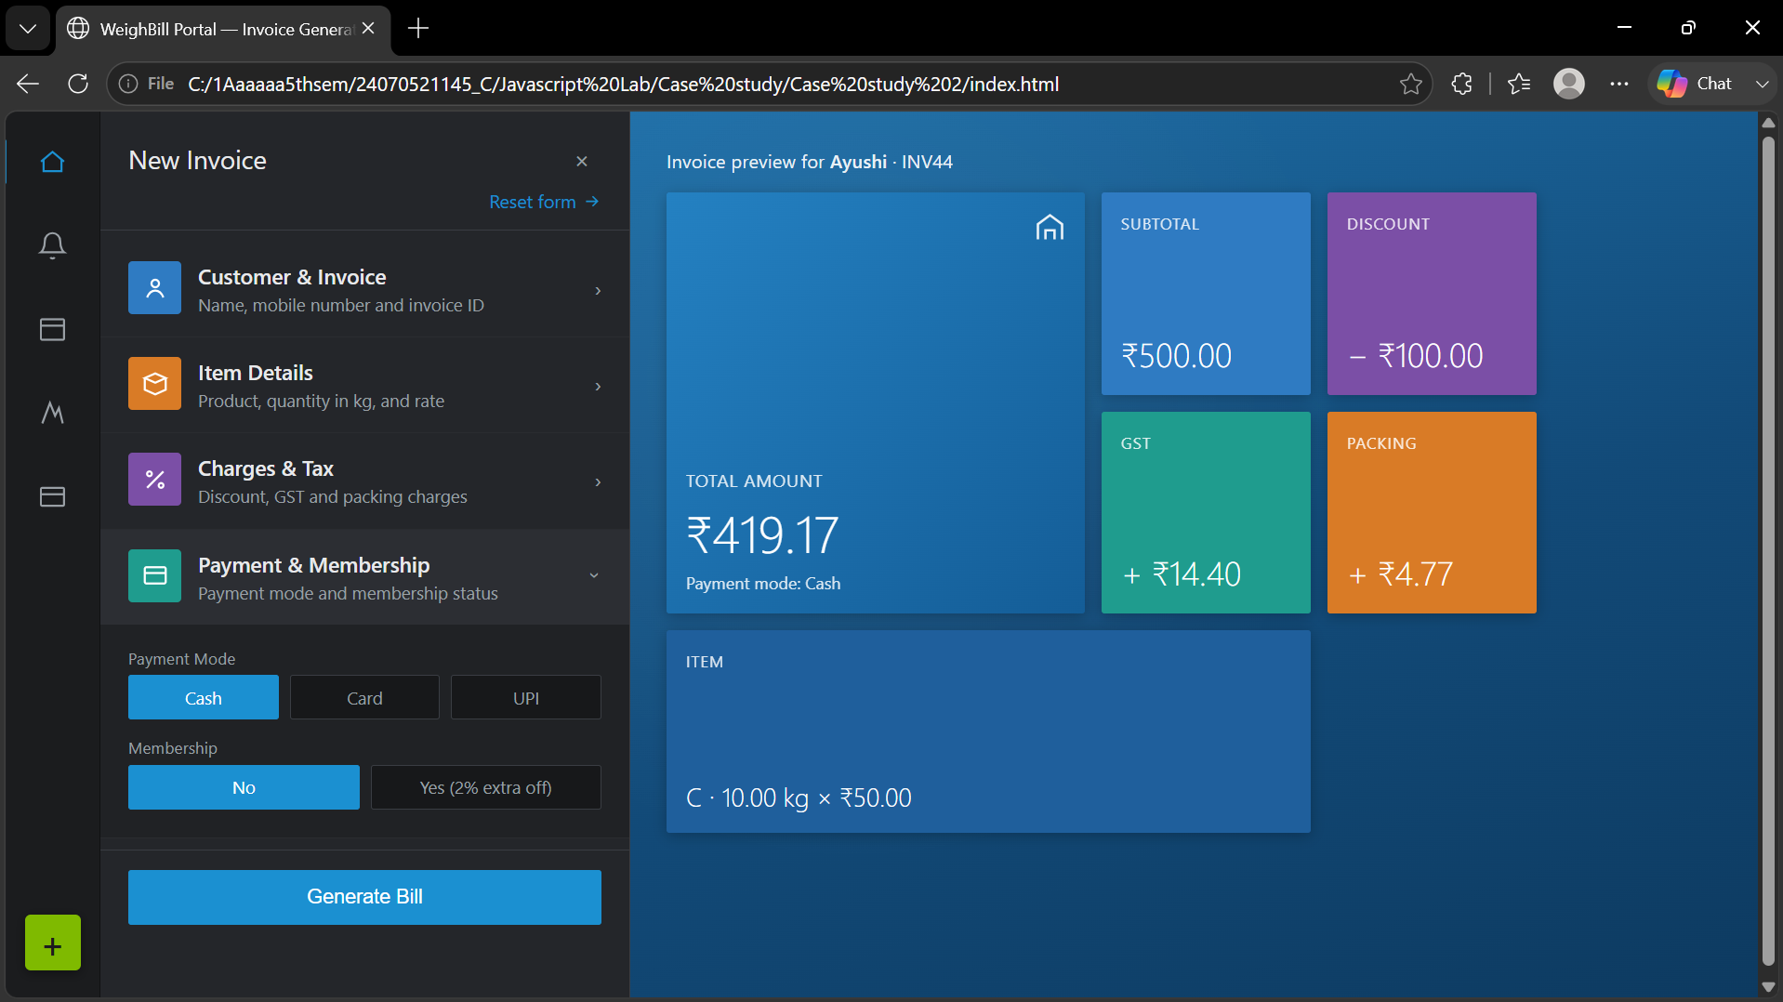

RESULT: The WeighBill Portal – Invoice Generator was successfully developed and executed. The system correctly accepts customer details, item information, discount, GST, packing charges, payment mode, and membership status. It automatically calculates the subtotal, applicable charges, and final payable amount, and generates a clear invoice preview with all billing details displayed accurately.

Experiment No.: 3
1.Title: Creating Grading system using HTML, CSS, JS.
2. Software/Tools Required: VSC, HTML, CSS
3. Theory:
A grading system is a client-side web application built using HTML, CSS, and JavaScript to convert student marks into grades and SGPA. HTML defines the structure (form, table, inputs), CSS handles the visual styling, and JavaScript performs DOM manipulation, event handling, and conditional logic (if-else) to validate marks and calculate grade points. The final SGPA is computed using the credit-weighted average formula (Σ Grade Points × Credits / Σ Credits), all processed instantly in the browser without needing a server.
CODE:
<!DOCTYPE html>
<html lang="en">
<head>
<meta charset="UTF-8">
<meta name="viewport" content="width=device-width, initial-scale=1.0">
<title>Semester Grade Sheet</title>
<style>
:root{
--deep: #0b3a56;
--deep2: #114f74;
--mid: #1c6f9c;

--sky: #cfe3f5;
--sky-light: #eaf3fb;
--ink: #0b2436;
--card-bg: rgba(255,255,255,0.86);
--glass-border: rgba(255,255,255,0.5);
}

*{ box-sizing: border-box; }

body{
margin:0;
min-height:100vh;
font-family: 'Segoe UI', system-ui, -apple-system, sans-serif;
color: var(--ink);
padding: 40px 16px 64px;
background:
radial-gradient(circle at 50% 38%, var(--mid) 0%, var(--deep2) 45%, var(--deep) 100%);
display:flex;
justify-content:center;
}

.sheet{
width: 100%;
max-width: 820px;
background: var(--card-bg);
backdrop-filter: blur(18px);
border: 1px solid var(--glass-border);
border-radius: 24px;
box-shadow: 0 30px 60px -20px rgba(6,25,40,0.55), 0 0 0 1px rgba(255,255,255,0.3) inset;
overflow: hidden;
position: relative;
}

.sheet::before{
content:"";
position:absolute;
top:0; left:0; right:0;
height: 6px;
background: linear-gradient(90deg, var(--deep), var(--mid), var(--sky));
}

header{
padding: 34px 40px 20px;

text-align:center;
background: linear-gradient(180deg, var(--sky-light) 0%, rgba(234,243,251,0) 100%);
}

.eyebrow{
font-size: 11px;
letter-spacing: 3px;
color: var(--mid);
text-transform: uppercase;
font-weight: 700;
margin: 0 0 8px;
}

h1{
font-size: 30px;
font-weight: 800;
margin: 0 0 4px;
color: var(--deep);
letter-spacing: -0.5px;
}

.subhead{
font-size: 13px;

color: #4a6376;
margin: 0;
}

.student-block{
padding: 22px 40px 4px;
display:grid;
grid-template-columns: 1fr 1fr;
gap: 16px;
}

.field{
display:flex;
flex-direction: column;
gap: 6px;
}

.field label{
font-size: 11px;
font-weight: 700;
letter-spacing: 1px;
text-transform: uppercase;
color: var(--mid);

}
.field input[type="text"]{
padding: 11px 14px;
border-radius: 12px;
border: 1.5px solid rgba(28,111,156,0.25);
background: #fff;
font-size: 14px;
color: var(--ink);
font-family: inherit;
}

.field input[type="text"]:focus{
outline: none;
border-color: var(--mid);
box-shadow: 0 0 0 3px rgba(28,111,156,0.15);
}

.grid{
padding: 26px 40px 8px;
}

table{
width: 100%;

border-collapse: collapse;
margin-bottom: 10px;
}

thead th{
text-align: left;
font-size: 10.5px;
letter-spacing: 1.5px;
text-transform: uppercase;
color: var(--mid);
font-weight: 700;
border-bottom: 2px solid rgba(28,111,156,0.2);
padding: 8px 10px;
}

tbody td{
padding: 12px 10px;
border-bottom: 1px solid rgba(28,111,156,0.12);
vertical-align: middle;
}

.code-cell{
font-weight: 800;

font-size: 15px;
color: var(--deep);
}

.code-cell small{
display:block;
font-weight: 500;
font-size: 11px;
color: #6b7d8a;
margin-top: 2px;
}

input[type="number"]{
width: 68px;
padding: 8px 10px;
border-radius: 10px;
border: 1.5px solid rgba(28,111,156,0.25);
background: #fff;
font-size: 14px;
color: var(--ink);
font-family: inherit;
}

input[type="number"]:focus{
outline: none;
border-color: var(--mid);
box-shadow: 0 0 0 3px rgba(28,111,156,0.15);
}

.credit-badge{
font-size: 11px;
color: #6b7d8a;
background: rgba(28,111,156,0.08);
padding: 3px 8px;
border-radius: 999px;
}

.grade-pill{
display:inline-block;
min-width: 36px;
text-align:center;
padding: 5px 10px;
font-weight: 800;
font-size: 12.5px;
border-radius: 999px;
color: var(--ink);

}

.grade-O{ background:#c9ecd6; }
.grade-Aplus{ background:#d8edc4; }
.grade-A{ background:#eee7b8; }
.grade-Bplus{ background:#f3d9a6; }
.grade-B{ background:#f2c79a; }
.grade-C{ background:#efb298; }
.grade-P{ background:#eba099; }
.grade-F{ background:#e28080; color:#4a1111; }

.result{
margin: 10px 40px 26px;
border-radius: 18px;
background: linear-gradient(135deg, var(--deep) 0%, var(--mid) 100%);
color: #eaf3fb;
padding: 22px 26px;
display:flex;
justify-content: space-between;
align-items: center;
flex-wrap: wrap;
gap: 16px;
box-shadow: 0 12px 30px -8px rgba(11,58,86,0.55);

}

.result .label{
font-size: 11px;
letter-spacing: 2px;
text-transform: uppercase;
color: var(--sky);
margin: 0 0 4px;
font-weight: 700;
}

.result .value{
font-size: 38px;
font-weight: 800;
margin: 0;
}

.result .who{
font-size: 12px;
color: var(--sky);
margin: 2px 0 0;
}

.

result .remark{
font-size: 13px;
color: #d7e8f4;
max-width: 260px;
text-align: right;
}

footer{
padding: 0 40px 30px;
display:flex;
justify-content: space-between;
align-items:center;
gap: 12px;
flex-wrap: wrap;
}

button{
font-family: inherit;
font-weight: 700;
letter-spacing: 0.5px;
font-size: 13px;
padding: 12px 22px;

border-radius: 12px;
border: none;
cursor: pointer;
transition: transform 0.12s ease, box-shadow 0.12s ease;
}

#calcBtn{
background: linear-gradient(135deg, var(--mid), var(--deep));
color: #fff;
box-shadow: 0 8px 18px -6px rgba(28,111,156,0.6);
}

#resetBtn{
background: rgba(28,111,156,0.1);
color: var(--deep);
}

button:hover{ transform: translateY(-1px); }
button:active{ transform: translateY(0); }
button:focus-visible{ outline: 2px solid var(--mid); outline-offset: 2px; }

.scale-note{

font-size: 11px;
color: #6b7d8a;
flex: 1;
min-width: 200px;
}

@media (max-width: 600px){
header, .student-block, .grid, .result, footer{ padding-left: 22px; padding-right: 22px; }
.student-block{ grid-template-columns: 1fr; }
.result{ flex-direction: column; align-items: flex-start; }
.result .remark{ text-align: left; }
input[type="number"]{ width: 56px; }
}
</style>
</head>
<body>

<div class="sheet">
<header>
<p class="eyebrow">B.Tech &middot; Computer Science &amp; Engineering</p>
<h1>Semester Grade Sheet</h1>
<p class="subhead">Enter your details and marks to compute grade points and SGPA</p>
</header>

<div class="student-block">
<div class="field">
<label for="studentName">Student Name</label>
<input type="text" id="studentName" placeholder="e.g. Aarav Sharma">
</div>
<div class="field">
<label for="studentPRN">PRN</label>
<input type="text" id="studentPRN" placeholder="e.g. 22070123456">
</div>
</div>

<div class="grid">
<table id="gradeTable">
<thead>
<tr>
<th>Subject</th>
<th>Credits</th>
<th>Marks&nbsp;/100</th>
<th>Grade</th>
<th>Points</th>
</tr>
</thead>

<tbody>
<!-- rows injected by JS -->
</tbody>
</table>
</div>

<div class="result">
<div>
<p class="label">SGPA</p>
<p class="value" id="sgpaValue">0.00</p>
<p class="who" id="whoLine">&nbsp;</p>
</div>
<p class="remark" id="remarkText">Enter marks above to see your standing.</p>
</div>

<footer>
<button id="calcBtn">Calculate</button>
<button id="resetBtn">Reset</button>
<div class="scale-note">Scale: O(90+)=10 &middot; A+(80-89)=9 &middot; A(70-79)=8 &middot; B+(60-69)=7 &middot; B(50-59)=6 &middot; C(45-49)=5 &middot; P(40-44)=4 &middot; F(&lt;40)=0</div>
</footer>
</div>

<script>
const subjects = [
{ code: "CN", name: "Computer Networks", credits: 4 },
{ code: "DC", name: "Distributed Computing", credits: 3 },
{ code: "CC", name: "Cloud Computing", credits: 3 },
{ code: "AIML", name: "AI &amp; Machine Learning", credits: 4 }
];

const tbody = document.querySelector("#gradeTable tbody");

function gradeClass(letter){
return "grade-" + letter.replace("+", "plus");
}

function computeGrade(marks){
if (marks >= 90) return { letter: "O", points: 10 };
if (marks >= 80) return { letter: "A+", points: 9 };
if (marks >= 70) return { letter: "A", points: 8 };
if (marks >= 60) return { letter: "B+", points: 7 };
if (marks >= 50) return { letter: "B", points: 6 };
if (marks >= 45) return { letter: "C", points: 5 };
if (marks >= 40) return { letter: "P", points: 4 };

return { letter: "F", points: 0 };
}

function buildRows(){
tbody.innerHTML = "";
subjects.forEach((subj, i) => {
const tr = document.createElement("tr");
tr.innerHTML = `
<td class="code-cell">${subj.code}<small>${subj.name}</small></td>
<td><span class="credit-badge">${subj.credits} cr</span></td>
<td>
<input type="number" step="1"
id="marks-${i}" placeholder="0" aria-label="${subj.name} marks">
</td>
<td><span class="grade-pill" id="grade-${i}">--</span></td>
<td id="points-${i}">--</td>
`;
tbody.appendChild(tr);
});
}

function calculate(){
let totalPoints = 0;

let totalCredits = 0;
let anyEntered = false;
let anyFail = false;
let anyInvalid = false;

subjects.forEach((subj, i) => {
const input = document.getElementById(`marks-${i}`);
const raw = input.value.trim();
const gradePill = document.getElementById(`grade-${i}`);
const pointsCell = document.getElementById(`points-${i}`);

if (raw === "") {
gradePill.textContent = "--";
gradePill.className = "grade-pill";
pointsCell.textContent = "--";
return;
}

let marks = Number(raw);

if (isNaN(marks) || marks < 0 || marks > 100) {
gradePill.textContent = "Invalid marks";

gradePill.className = "grade-pill grade-F";
pointsCell.textContent = "--";
input.style.borderColor = "#e28080";
anyInvalid = true;
return;
}
input.style.borderColor = "";

anyEntered = true;
const { letter, points } = computeGrade(marks);
if (letter === "F") anyFail = true;

gradePill.textContent = letter;
gradePill.className = "grade-pill " + gradeClass(letter);
pointsCell.textContent = points.toFixed(1);

totalPoints += points * subj.credits;
totalCredits += subj.credits;
});

const sgpaValue = document.getElementById("sgpaValue");
const remarkText = document.getElementById("remarkText");
const whoLine = document.getElementById("whoLine");

const name = document.getElementById("studentName").value.trim();
const prn = document.getElementById("studentPRN").value.trim();

let parts = [];
if (name) parts.push(name);
if (prn) parts.push("PRN " + prn);
whoLine.textContent = parts.join(" — ");

if (!anyEntered || totalCredits === 0) {
sgpaValue.textContent = "0.00";
remarkText.textContent = "Enter marks above to see your standing.";
return;
}

const sgpa = totalPoints / totalCredits;
sgpaValue.textContent = sgpa.toFixed(2);

if (anyInvalid) {
remarkText.textContent = "Invalid marks, please enter valid marks.";
} else if (anyFail) {
remarkText.textContent = "One or more subjects below passing marks — check the F grade above.";
} else if (sgpa >= 9) {
R

emarkText.textContent = "Outstanding semester — well above average.";
} else if (sgpa >= 8) {
remarkText.textContent = "Strong semester, solidly in the top band.";
} else if (sgpa >= 7) {
remarkText.textContent = "Good, consistent performance this semester.";
} else if (sgpa >= 6) {
remarkText.textContent = "Passing comfortably — room to push higher.";
} else {
remarkText.textContent = "Clearing, but worth reviewing weaker subjects.";
}
}

function resetAll(){
buildRows();
document.getElementById("studentName").value = "";
document.getElementById("studentPRN").value = "";
document.getElementById("sgpaValue").textContent = "0.00";
document.getElementById("remarkText").textContent = "Enter marks above to see your standing.";
document.getElementById("whoLine").textContent = "";
}

document.getElementById("calcBtn").addEventListener("click", calculate);

document.getElementById("resetBtn").addEventListener("click", resetAll);

buildRows();
</script>

</body>
</html>
4. Output:
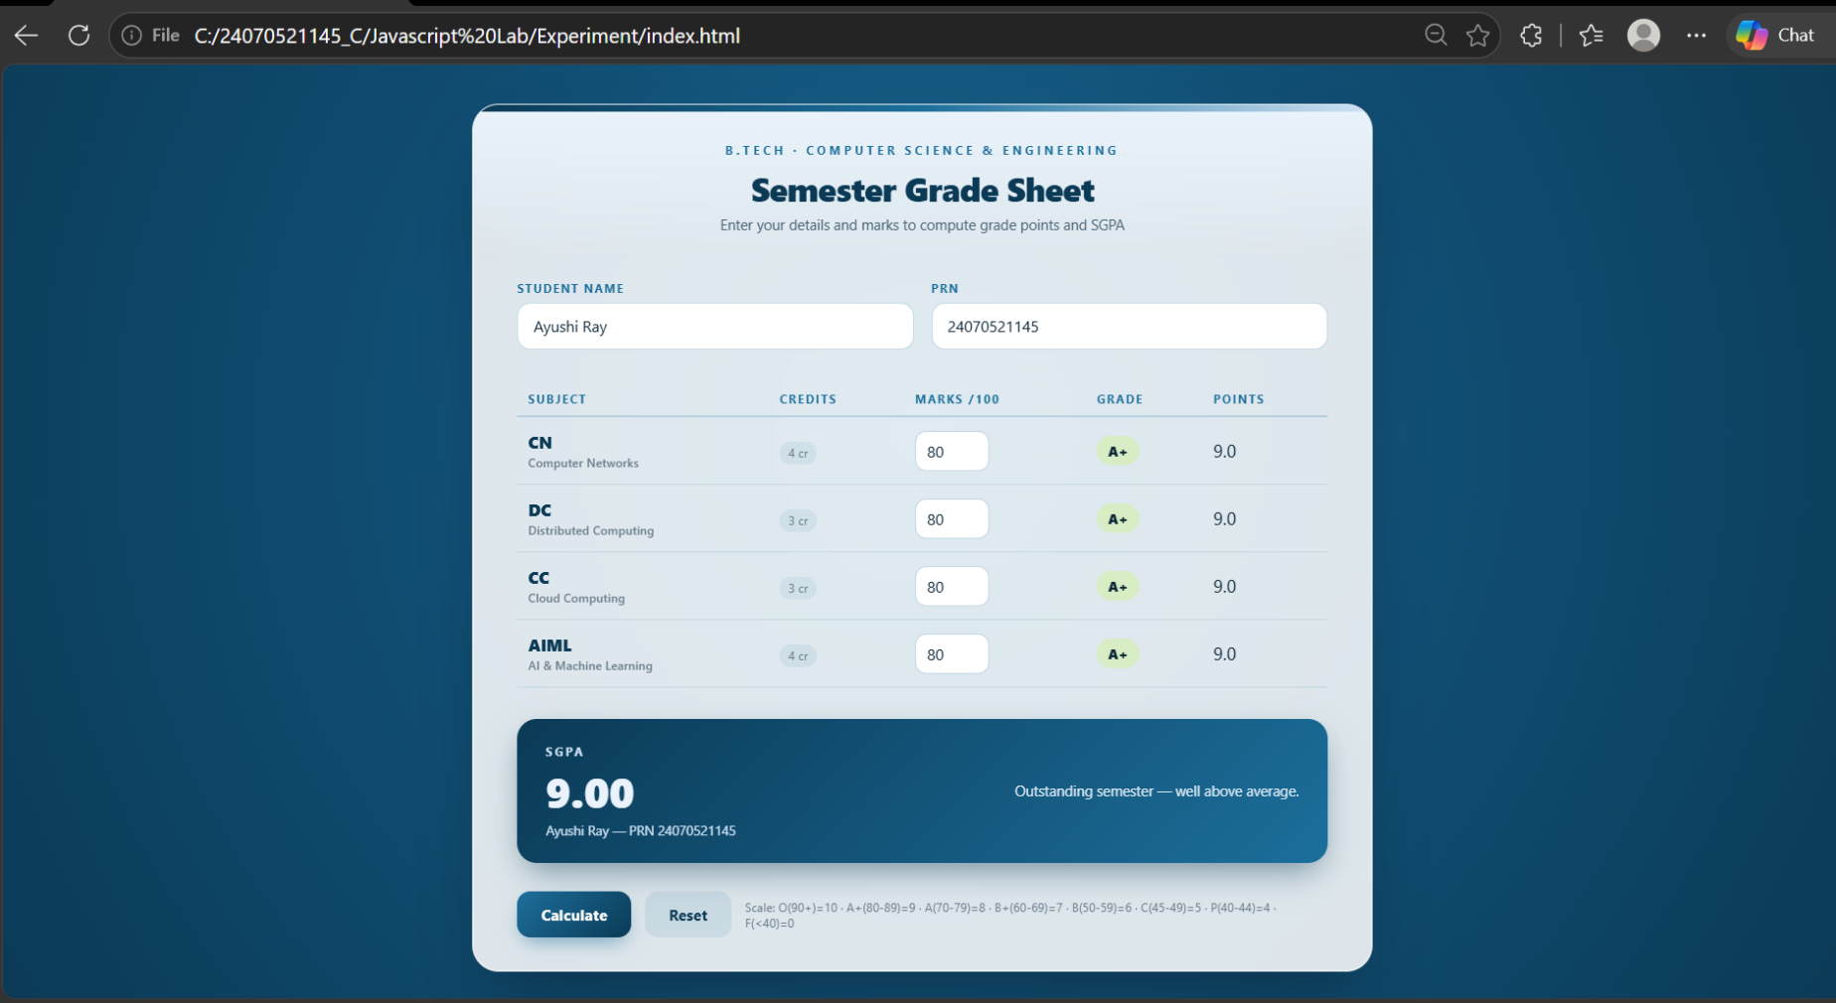

5. Result/Conclusion:
The webpage was successfully created using inline, internal, and external CSS. Different styling methods were implemented and compared, and the webpage displayed the required content with the desired formatting.

Case Study: 3
Title: To design a web application with a login system that allows only authenticated users to access a Semester Grade Sheet, where students can enter their marks and get their SGPA calculated automatically.
Software/Tools Required: VSC, HTML, CSS, JavaScript
Case Study program code:
INDEX:
<!DOCTYPE html>
<html lang="en">
<head>
<meta charset="UTF-8">
<meta name="viewport" content="width=device-width, initial-scale=1.0">
<title>Semester Grade Sheet</title>
<style>
:root{
--deep: #0b3a56;
--deep2: #114f74;
--mid: #1c6f9c;
--sky: #cfe3f5;
--sky-light: #eaf3fb;
--ink: #0b2436;
--card-bg: rgba(255,255,255,0.86);
--glass-border: rgba(255,255,255,0.5);

}

*{ box-sizing: border-box; }

body{
margin:0;
min-height:100vh;
font-family: 'Segoe UI', system-ui, -apple-system, sans-serif;
color: var(--ink);
padding: 40px 16px 64px;
background:
radial-gradient(circle at 50% 38%, var(--mid) 0%, var(--deep2) 45%, var(--deep) 100%);
display:flex;
justify-content:center;
}

.sheet{
width: 100%;
max-width: 820px;
background: var(--card-bg);
backdrop-filter: blur(18px);
border: 1px solid var(--glass-border);
border-radius: 24px;
box-shadow: 0 30px 60px -20px rgba(6,25,40,0.55), 0 0 0 1px rgba(255,255,255,0.3) inset;

overflow: hidden;
position: relative;
}

.sheet::before{
content:"";
position:absolute;
top:0; left:0; right:0;
height: 6px;
background: linear-gradient(90deg, var(--deep), var(--mid), var(--sky));
}

header{
padding: 34px 40px 20px;
text-align:center;
background: linear-gradient(180deg, var(--sky-light) 0%, rgba(234,243,251,0) 100%);
}

.eyebrow{
font-size: 11px;
letter-spacing: 3px;
color: var(--mid);
text-transform: uppercase;
font-weight: 700;
margin: 0 0 8px;

}

h1{
font-size: 30px;
font-weight: 800;
margin: 0 0 4px;
color: var(--deep);
letter-spacing: -0.5px;
}

.subhead{
font-size: 13px;
color: #4a6376;
margin: 0;
}

.student-block{
padding: 22px 40px 4px;
display:grid;
grid-template-columns: 1fr 1fr;
gap: 16px;
}

.field{

display:flex;
flex-direction: column;
gap: 6px;
}

.field label{
font-size: 11px;
font-weight: 700;
letter-spacing: 1px;
text-transform: uppercase;
color: var(--mid);
}

.field input[type="text"]{
padding: 11px 14px;
border-radius: 12px;
border: 1.5px solid rgba(28,111,156,0.25);
background: #fff;
font-size: 14px;
color: var(--ink);
font-family: inherit;
}

.field input[type="text"]:focus{
outline: none;

border-color: var(--mid);
box-shadow: 0 0 0 3px rgba(28,111,156,0.15);
}

.grid{
padding: 26px 40px 8px;
}

table{
width: 100%;
border-collapse: collapse;
margin-bottom: 10px;
}

thead th{
text-align: left;
font-size: 10.5px;
letter-spacing: 1.5px;
text-transform: uppercase;
color: var(--mid);
font-weight: 700;
border-bottom: 2px solid rgba(28,111,156,0.2);
padding: 8px 10px;
}

tbody td{
padding: 12px 10px;
border-bottom: 1px solid rgba(28,111,156,0.12);
vertical-align: middle;
}

.code-cell{
font-weight: 800;
font-size: 15px;
color: var(--deep);
}

.code-cell small{
display:block;
font-weight: 500;
font-size: 11px;
color: #6b7d8a;
margin-top: 2px;
}

input[type="number"]{
width: 68px;
padding: 8px 10px;
border-radius: 10px;
border: 1.5px solid rgba(28,111,156,0.25);

background: #fff;
font-size: 14px;
color: var(--ink);
font-family: inherit;
}

input[type="number"]:focus{
outline: none;
border-color: var(--mid);
box-shadow: 0 0 0 3px rgba(28,111,156,0.15);
}

.credit-badge{
font-size: 11px;
color: #6b7d8a;
background: rgba(28,111,156,0.08);
padding: 3px 8px;
border-radius: 999px;
}

.grade-pill{
display:inline-block;
min-width: 36px;
text-align:center;

padding: 5px 10px;
font-weight: 800;
font-size: 12.5px;
border-radius: 999px;
color: var(--ink);
}

.grade-O{ background:#c9ecd6; }
.grade-Aplus{ background:#d8edc4; }
.grade-A{ background:#eee7b8; }
.grade-Bplus{ background:#f3d9a6; }
.grade-B{ background:#f2c79a; }
.grade-C{ background:#efb298; }
.grade-P{ background:#eba099; }
.grade-F{ background:#e28080; color:#4a1111; }

.result{
margin: 10px 40px 26px;
border-radius: 18px;
background: linear-gradient(135deg, var(--deep) 0%, var(--mid) 100%);
color: #eaf3fb;
padding: 22px 26px;
display:flex;
justify-content: space-between;
align-items: center;

flex-wrap: wrap;
gap: 16px;
box-shadow: 0 12px 30px -8px rgba(11,58,86,0.55);
}

.result .label{
font-size: 11px;
letter-spacing: 2px;
text-transform: uppercase;
color: var(--sky);
margin: 0 0 4px;
font-weight: 700;
}

.result .value{
font-size: 38px;
font-weight: 800;
margin: 0;
}

.result .who{
font-size: 12px;
color: var(--sky);
margin: 2px 0 0;
}

.result .remark{
font-size: 13px;
color: #d7e8f4;
max-width: 260px;
text-align: right;
}

footer{
padding: 0 40px 30px;
display:flex;
justify-content: space-between;
align-items:center;
gap: 12px;
flex-wrap: wrap;
}

button{
font-family: inherit;
font-weight: 700;
letter-spacing: 0.5px;
font-size: 13px;
padding: 12px 22px;
border-radius: 12px;
border: none;

cursor: pointer;
transition: transform 0.12s ease, box-shadow 0.12s ease;
}

#calcBtn{
background: linear-gradient(135deg, var(--mid), var(--deep));
color: #fff;
box-shadow: 0 8px 18px -6px rgba(28,111,156,0.6);
}

#resetBtn{
background: rgba(28,111,156,0.1);
color: var(--deep);
}

button:hover{ transform: translateY(-1px); }
button:active{ transform: translateY(0); }
button:focus-visible{ outline: 2px solid var(--mid); outline-offset: 2px; }

.scale-note{
font-size: 11px;
color: #6b7d8a;
flex: 1;
min-width: 200px;

}

@media (max-width: 600px){
header, .student-block, .grid, .result, footer{ padding-left: 22px; padding-right: 22px; }
.student-block{ grid-template-columns: 1fr; }
.result{ flex-direction: column; align-items: flex-start; }
.result .remark{ text-align: left; }
input[type="number"]{ width: 56px; }
}

/* ---- Login overlay ---- */
#loginOverlay{
position: fixed;
inset: 0;
background: radial-gradient(circle at 50% 38%, var(--mid) 0%, var(--deep2) 45%, var(--deep) 100%);
display:flex;
justify-content:center;
align-items:center;
padding: 16px;
z-index: 1000;
}

#loginOverlay .login-card{
width: 100%;
max-width: 400px;

background: var(--card-bg);
backdrop-filter: blur(18px);
border: 1px solid var(--glass-border);
border-radius: 24px;
box-shadow: 0 30px 60px -20px rgba(6,25,40,0.55), 0 0 0 1px rgba(255,255,255,0.3) inset;
overflow: hidden;
position: relative;
}

#loginOverlay .login-card::before{
content:"";
position:absolute;
top:0; left:0; right:0;
height: 6px;
background: linear-gradient(90deg, var(--deep), var(--mid), var(--sky));
}

#loginOverlay header{
padding: 34px 36px 16px;
}

#loginOverlay h1{
font-size: 24px;
}

#loginOverlay form{
padding: 18px 36px 6px;
display:flex;
flex-direction: column;
gap: 16px;
}

#loginOverlay .field label{
font-size: 11px;
font-weight: 700;
letter-spacing: 1px;
text-transform: uppercase;
color: var(--mid);
}

#loginOverlay .field input{
width: 100%;
padding: 11px 14px;
border-radius: 12px;
border: 1.5px solid rgba(28,111,156,0.25);
background: #fff;
font-size: 14px;
color: var(--ink);
font-family: inherit;

}

#loginOverlay .field input:focus{
outline: none;
border-color: var(--mid);
box-shadow: 0 0 0 3px rgba(28,111,156,0.15);
}

#loginError{
font-size: 12.5px;
color: #b23b3b;
min-height: 16px;
margin: -4px 0 0;
}

#loginOverlay footer{
padding: 6px 36px 30px;
display:flex;
flex-direction: column;
gap: 10px;
}

#loginBtn{
width: 100%;
background: linear-gradient(135deg, var(--mid), var(--deep));

color: #fff;
box-shadow: 0 8px 18px -6px rgba(28,111,156,0.6);
}

.login-hint{
font-size: 11px;
color: #6b7d8a;
text-align:center;
}

body.locked > .sheet{
display: none;
}
</style>
</head>
<body class="locked">

<div id="loginOverlay">
<div class="login-card">
<header>
<p class="eyebrow">B.Tech &middot; Computer Science &amp; Engineering</p>
<h1>Student Login</h1>
<p class="subhead">Sign in to access your Semester Grade Sheet</p>
</header>

<form id="loginForm">
<div class="field">
<label for="loginUsername">Username</label>
<input type="text" id="loginUsername" placeholder="e.g. student" autocomplete="username" required>
</div>
<div class="field">
<label for="loginPassword">Password</label>
<input type="password" id="loginPassword" placeholder="Enter password" autocomplete="current-password" required>
</div>
<p id="loginError"></p>
</form>

<footer>
<button id="loginBtn" type="submit" form="loginForm">Login</button>
<p class="login-hint">Demo credentials — username: <b>student</b>, password: <b>1234</b></p>
</footer>
</div>
</div>

<div class="sheet">
<header>
<p class="eyebrow">B.Tech &middot; Computer Science &amp; Engineering</p>
<h1>Semester Grade Sheet</h1>

<p class="subhead">Enter your details and marks to compute grade points and SGPA</p>
</header>

<div class="student-block">
<div class="field">
<label for="studentName">Student Name</label>
<input type="text" id="studentName" placeholder="e.g. Aarav Sharma">
</div>
<div class="field">
<label for="studentPRN">PRN</label>
<input type="text" id="studentPRN" placeholder="e.g. 22070123456">
</div>
</div>

<div class="grid">
<table id="gradeTable">
<thead>
<tr>
<th>Subject</th>
<th>Credits</th>
<th>Marks&nbsp;/100</th>
<th>Grade</th>
<th>Points</th>
</tr>
</thead>

<tbody>
<!-- rows injected by JS -->
</tbody>
</table>
</div>

<div class="result">
<div>
<p class="label">SGPA</p>
<p class="value" id="sgpaValue">0.00</p>
<p class="who" id="whoLine">&nbsp;</p>
</div>
<p class="remark" id="remarkText">Enter marks above to see your standing.</p>
</div>

<footer>
<button id="calcBtn">Calculate</button>
<button id="resetBtn">Reset</button>
<div class="scale-note">Scale: O(90+)=10 &middot; A+(80-89)=9 &middot; A(70-79)=8 &middot; B+(60-69)=7 &middot; B(50-59)=6 &middot; C(45-49)=5 &middot; P(40-44)=4 &middot; F(&lt;40)=0</div>
</footer>
</div>

<script>
// ---- Simple client-side login gate (no backend) ----

// Change these to whatever you like, or wire this up to a real backend later.
const VALID_USERNAME = "Ayushi";
const VALID_PASSWORD = "Ayushi_24070521145!@#";

const loginForm = document.getElementById("loginForm");
const loginError = document.getElementById("loginError");
const loginOverlay = document.getElementById("loginOverlay");

// Stay logged in for this browser tab session
if (sessionStorage.getItem("loggedIn") === "true") {
document.body.classList.remove("locked");
loginOverlay.style.display = "none";
}

loginForm.addEventListener("submit", function (e) {
e.preventDefault();
const username = document.getElementById("loginUsername").value.trim();
const password = document.getElementById("loginPassword").value;

if (username === VALID_USERNAME && password === VALID_PASSWORD) {
loginError.textContent = "";
sessionStorage.setItem("loggedIn", "true");
document.body.classList.remove("locked");
loginOverlay.style.display = "none";
} else {

loginError.textContent = "Invalid username or password. Please try again.";
}
});

const subjects = [
{ code: "CN", name: "Computer Networks", credits: 4 },
{ code: "DC", name: "Distributed Computing", credits: 3 },
{ code: "CC", name: "Cloud Computing", credits: 3 },
{ code: "AIML", name: "AI &amp; Machine Learning", credits: 4 }
];

const tbody = document.querySelector("#gradeTable tbody");

function gradeClass(letter){
return "grade-" + letter.replace("+", "plus");
}

function computeGrade(marks){
if (marks >= 90) return { letter: "O", points: 10 };
if (marks >= 80) return { letter: "A+", points: 9 };
if (marks >= 70) return { letter: "A", points: 8 };
if (marks >= 60) return { letter: "B+", points: 7 };
if (marks >= 50) return { letter: "B", points: 6 };
if (marks >= 45) return { letter: "C", points: 5 };
if (marks >= 40) return { letter: "P", points: 4 };

return { letter: "F", points: 0 };
}

function buildRows(){
tbody.innerHTML = "";
subjects.forEach((subj, i) => {
const tr = document.createElement("tr");
tr.innerHTML = `
<td class="code-cell">${subj.code}<small>${subj.name}</small></td>
<td><span class="credit-badge">${subj.credits} cr</span></td>
<td>
<input type="number" step="1"
id="marks-${i}" placeholder="0" aria-label="${subj.name} marks">
</td>
<td><span class="grade-pill" id="grade-${i}">--</span></td>
<td id="points-${i}">--</td>
`;
tbody.appendChild(tr);
});
}

function calculate(){
let totalPoints = 0;
let totalCredits = 0;
let anyEntered = false;

let anyFail = false;
let anyInvalid = false;

subjects.forEach((subj, i) => {
const input = document.getElementById(`marks-${i}`);
const raw = input.value.trim();
const gradePill = document.getElementById(`grade-${i}`);
const pointsCell = document.getElementById(`points-${i}`);

if (raw === "") {
gradePill.textContent = "--";
gradePill.className = "grade-pill";
pointsCell.textContent = "--";
return;
}

let marks = Number(raw);

if (isNaN(marks) || marks < 0 || marks > 100) {
gradePill.textContent = "Invalid marks";
gradePill.className = "grade-pill grade-F";
pointsCell.textContent = "--";
input.style.borderColor = "#e28080";
anyInvalid = true;
return;
}

input.style.borderColor = "";

anyEntered = true;
const { letter, points } = computeGrade(marks);
if (letter === "F") anyFail = true;

gradePill.textContent = letter;
gradePill.className = "grade-pill " + gradeClass(letter);
pointsCell.textContent = points.toFixed(1);

totalPoints += points * subj.credits;
totalCredits += subj.credits;
});

const sgpaValue = document.getElementById("sgpaValue");
const remarkText = document.getElementById("remarkText");
const whoLine = document.getElementById("whoLine");

const name = document.getElementById("studentName").value.trim();
const prn = document.getElementById("studentPRN").value.trim();

let parts = [];
if (name) parts.push(name);
if (prn) parts.push("PRN " + prn);
whoLine.textContent = parts.join(" — ");

if (!anyEntered || totalCredits === 0) {
sgpaValue.textContent = "0.00";
remarkText.textContent = "Enter marks above to see your standing.";
return;
}

const sgpa = totalPoints / totalCredits;
sgpaValue.textContent = sgpa.toFixed(2);

if (anyInvalid) {
remarkText.textContent = "Invalid marks, please enter valid marks.";
} else if (anyFail) {
remarkText.textContent = "One or more subjects below passing marks — check the F grade above.";
} else if (sgpa >= 9) {
remarkText.textContent = "Outstanding semester — well above average.";
} else if (sgpa >= 8) {
remarkText.textContent = "Strong semester, solidly in the top band.";
} else if (sgpa >= 7) {
remarkText.textContent = "Good, consistent performance this semester.";
} else if (sgpa >= 6) {
remarkText.textContent = "Passing comfortably — room to push higher.";
} else {
remarkText.textContent = "Clearing, but worth reviewing weaker subjects.";
}

}

function resetAll(){
buildRows();
document.getElementById("studentName").value = "";
document.getElementById("studentPRN").value = "";
document.getElementById("sgpaValue").textContent = "0.00";
document.getElementById("remarkText").textContent = "Enter marks above to see your standing.";
document.getElementById("whoLine").textContent = "";
}

document.getElementById("calcBtn").addEventListener("click", calculate);
document.getElementById("resetBtn").addEventListener("click", resetAll);

buildRows();
</script>

</body>
</html>

OUTPUT:
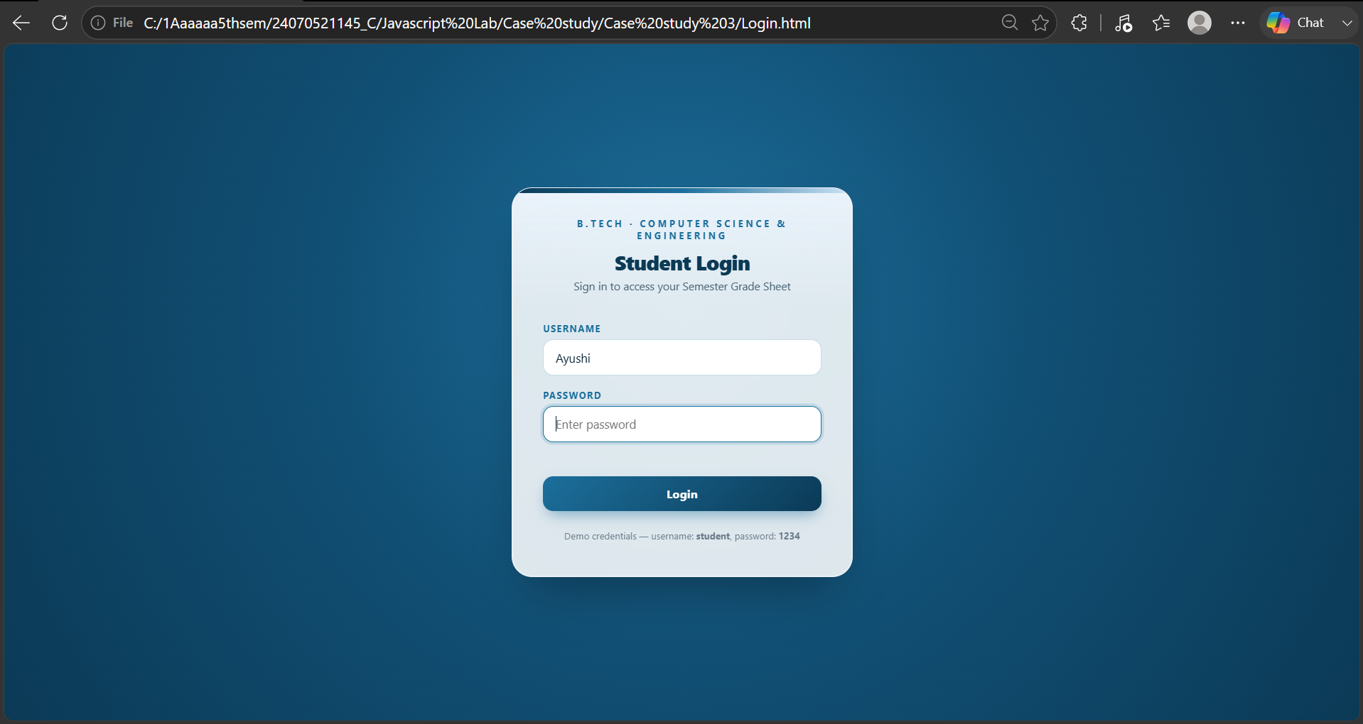
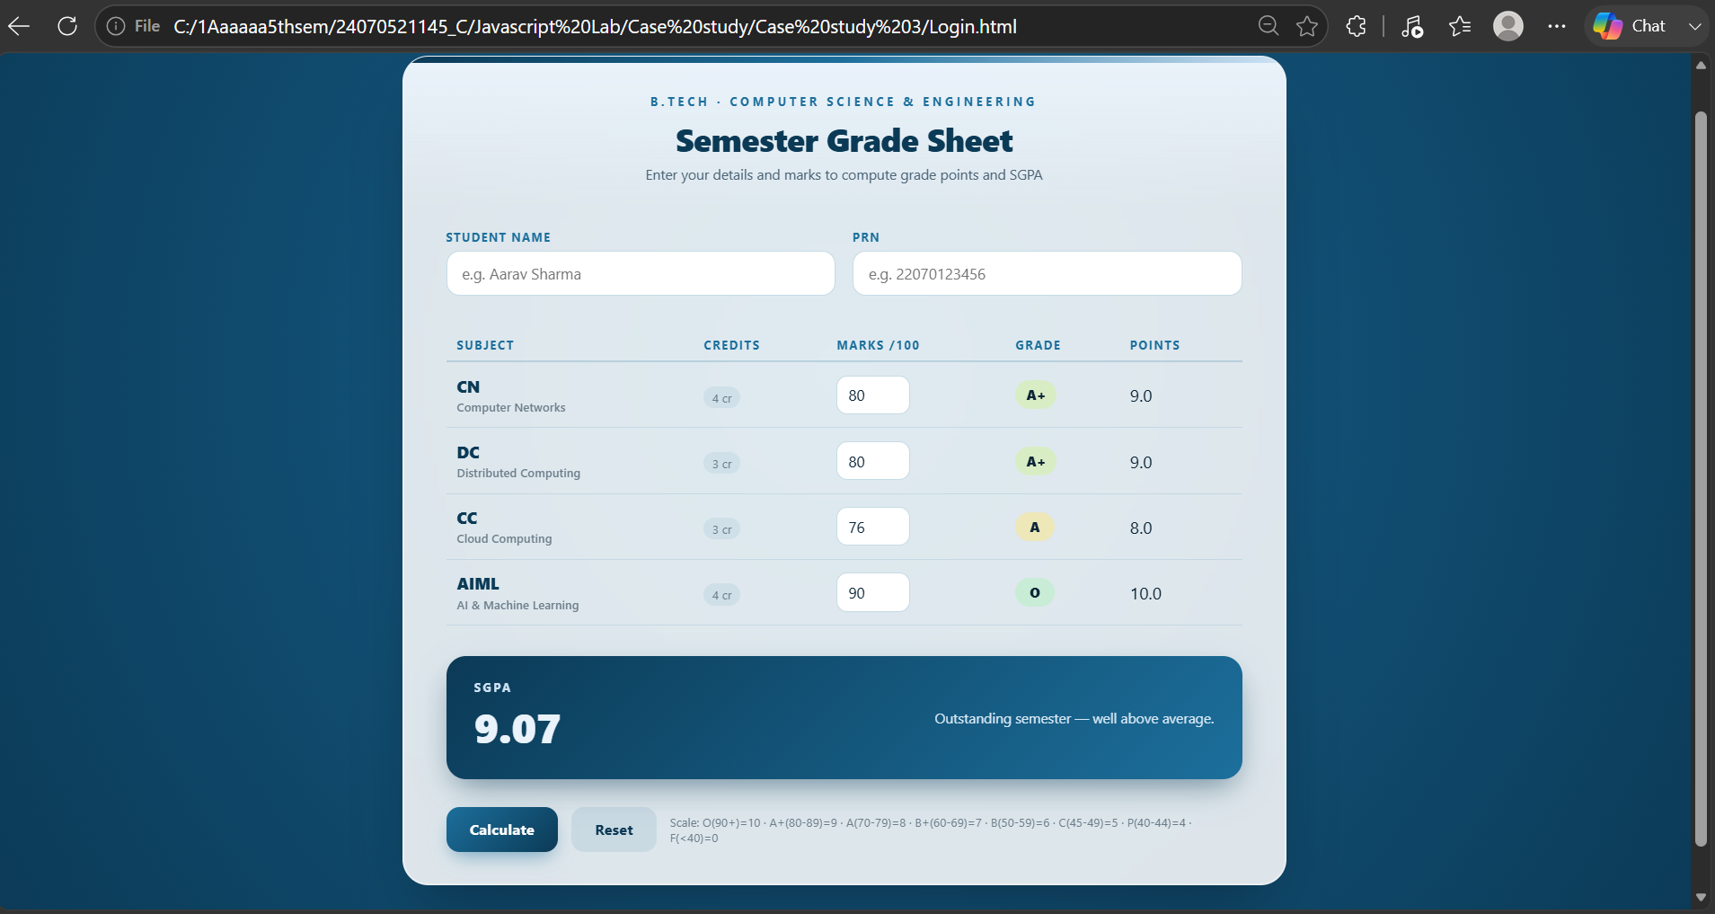
RESULT:
Thus, a web application was successfully designed which allows secure login access using JavaScript and sessionStorage, and calculates a student's SGPA based on entered marks. The program demonstrates the use of DOM manipulation, event handling, conditional logic, and session-based data storage to build a practical, interactive tool.

Experiment No.: 4
1.Title: To develop a JavaScript-based web application that checks whether a given string is a palindrome, while demonstrating the use of function declarations, function expressions, arrow functions, closures, and exception handling (try-catch) in JavaScript.
2. Software/Tools Required: VSC, HTML, CSS
3. Theory:
A palindrome is a word that reads the same backward as forward, like "madam" or "racecar".
In this program, we check this in a simple way:
- A function is written that reverses the string and checks if the reversed string is the same as the original. If they match, the word is a palindrome.
- Before checking, the input is cleaned up — all letters are converted to lowercase and spaces/symbols are removed. This way, even phrases like "Madam" are checked correctly.
- A counter is also used to keep track of how many times the user has checked a word. This counter remembers its value between clicks — this is called a closure.
- If the user clicks "Check" without typing anything, the program doesn't crash. Instead, try-catch is used to show a proper error message.
- Finally, JavaScript is connected to the HTML page to take input from the user and show the result on the screen.

Code:
<!DOCTYPE html>
<html lang="en">
<head>
<meta charset="UTF-8">
<title>Palindrome Checker</title>
<style>
body {
font-family: Arial, sans-serif;
background: #1e1e2f;
color: #eee;
display: flex;
justify-content: center;
padding-top: 60px;
}
.box {
background: #2a2a3d;
padding: 30px;
border-radius: 10px;
width: 350px;
}
h2 { margin-top: 0; text-align: center; }
input {
width: 100%;
padding: 10px;
font-size: 15px;
border-radius: 5px;

border: none;
margin-bottom: 12px;
box-sizing: border-box;
}
button {
width: 100%;
padding: 10px;
background: #4CAF50;
color: white;
border: none;
border-radius: 5px;
font-size: 15px;
cursor: pointer;
}
button:hover { background: #45a049; }
#result {
margin-top: 15px;
text-align: center;
font-weight: bold;
min-height: 20px;
}
</style>
</head>
<body>

<div class="box">

<h2>Palindrome Checker</h2>
<input type="text" id="wordInput" placeholder="Enter a word">
<button onclick="handleCheck()">Check</button>
<p id="result"></p>
</div>

<script>

// 1. FUNCTION DECLARATION
// Basic logic: checks if a string reads the same forward and backward
function isPalindrome(str) {
let reversed = str.split("").reverse().join(""); // local scope variable
return str === reversed;
}

// 2. FUNCTION EXPRESSION
// Cleans the input: lowercase + removes spaces/punctuation
const cleanInput = function (str) {
return str.toLowerCase().replace(/[^a-z0-9]/g, "");
};

// 3. ARROW FUNCTION
// Simple counter using a closure to remember how many times we checked
let countChecks = (function () {
let count = 0; // private variable, remembered via closure
return () => ++count;
})();

// 4. FUNCTION using TRY-CATCH
// Handles bad input safely without crashing the page
function handleCheck() {
const resultEl = document.getElementById("result");

try {
const input = document.getElementById("wordInput").value;

if (!input || input.trim() === "") {
throw new Error("Please enter something to check.");
}

const cleaned = cleanInput(input);
const result = isPalindrome(cleaned);
const attempt = countChecks();

resultEl.style.color = result ? "#4CAF50" : "#e57373";
resultEl.textContent = result
? `✓ "${input}" is a palindrome (check #${attempt})`
: `✗ "${input}" is not a palindrome (check #${attempt})`;

} catch (err) {
resultEl.style.color = "#e57373";
resultEl.textContent = "⚠ " + err.message;
}
}

</script>
</body>
</html>
4. Output:
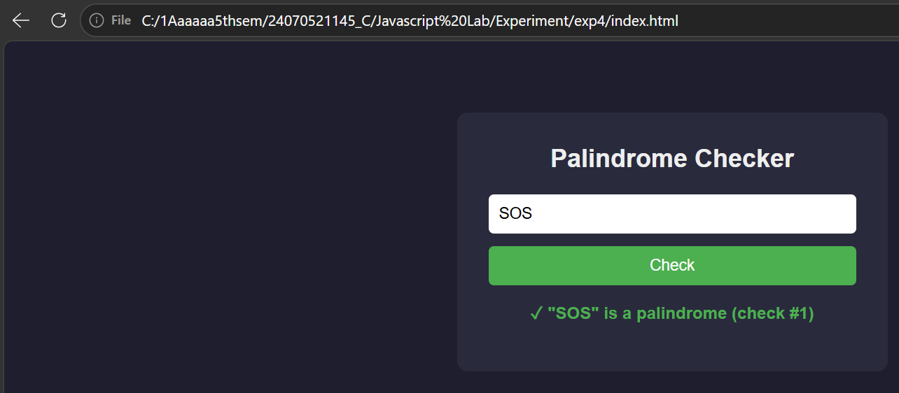
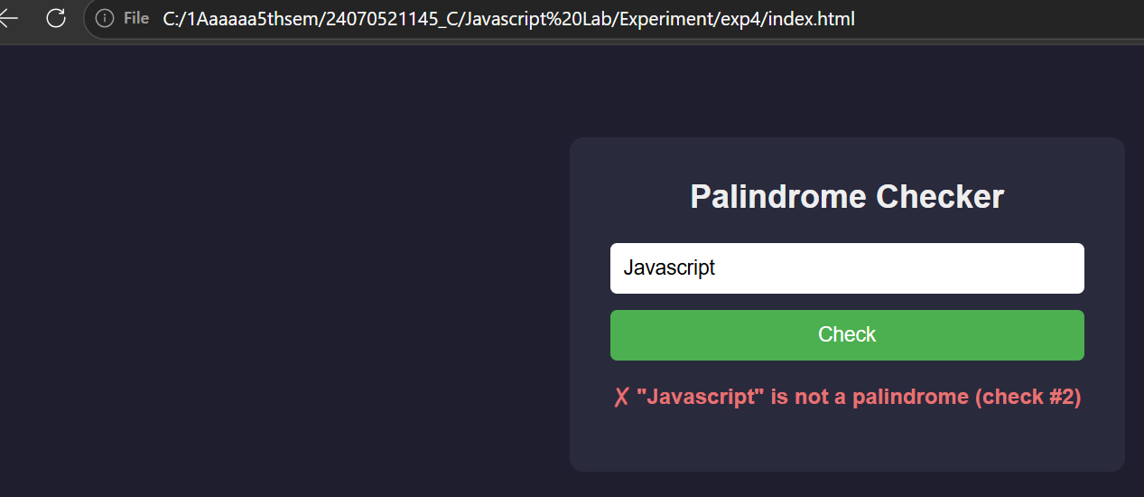

5. Result/Conclusion: Thus, a JavaScript program to check whether a given string is a palindrome was successfully designed and implemented. The program demonstrates the practical application of function declarations, function expressions, arrow functions, closures, and try-catch exception handling, along with basic DOM manipulation for building interactive web applications.

Case Study: 4
Title: Development of password strength checker using HTML,CSS.
Software/Tools Required: VSC, HTML, CSS, JavaScript
Case Study program code:
<!DOCTYPE html>
<html lang="en">
<head>
<meta charset="UTF-8">
<title>Password Checker</title>
<style>
body {
font-family: Arial, sans-serif;
background: #1e1e2f;
color: #eee;
display: flex;
justify-content: center;
padding-top: 60px;
}
.box {
background: #2a2a3d;
padding: 30px;
border-radius: 10px;
width: 350px;

}
h2 { margin-top: 0; text-align: center; }
.pwd-wrap {
position: relative;
margin-bottom: 12px;
}
input {
width: 100%;
padding: 10px;
padding-right: 40px;
font-size: 15px;
border-radius: 5px;
border: none;
box-sizing: border-box;
}
.toggle-eye {
position: absolute;
right: 10px;
top: 50%;
transform: translateY(-50%);
cursor: pointer;
font-size: 16px;
user-select: none;
}
button {

width: 100%;
padding: 10px;
background: #4CAF50;
color: white;
border: none;
border-radius: 5px;
font-size: 15px;
cursor: pointer;
}
button:hover { background: #45a049; }
#result {
margin-top: 15px;
text-align: center;
font-weight: bold;
min-height: 20px;
}
</style>
</head>
<body>

<div class="box">
<h2>Password Checker</h2>
<div class="pwd-wrap">
<input type="password" id="pwdInput" placeholder="Enter a password">
<span class="toggle-eye" id="toggleEye" onclick="togglePassword()">👁️</span>

</div>
<button onclick="handleCheck()">Check</button>
<p id="result"></p>
</div>

<script>

// Checks if a string reads the same forward and backward
function isPalindrome(str) {
let reversed = str.split("").reverse().join("");
return str === reversed;
}

// Basic strength check: length + uppercase + number + special char
function isStrongPassword(str) {
const hasLength = str.length >= 8;
const hasUpper = /[A-Z]/.test(str);
const hasNumber = /[0-9]/.test(str);
const hasSpecial = /[^a-zA-Z0-9]/.test(str);

return hasLength && hasUpper && hasNumber && hasSpecial;
}

// Toggles password field between hidden (dots) and visible (text)
function togglePassword() {

const pwdInput = document.getElementById("pwdInput");
const eyeIcon = document.getElementById("toggleEye");

if (pwdInput.type === "password") {
pwdInput.type = "text";
eyeIcon.textContent = "👁";
} else {
pwdInput.type = "password";
eyeIcon.textContent = "👁";
}
}

function handleCheck() {
const resultEl = document.getElementById("result");

try {
const pwd = document.getElementById("pwdInput").value;

if (!pwd || pwd.trim() === "") {
throw new Error("Please enter a password.");
}

if (isPalindrome(pwd)) {
resultEl.style.color = "#e57373";
resultEl.textContent = "✗ Weak — password is a palindrome";

return;
}

if (isStrongPassword(pwd)) {
resultEl.style.color = "#4CAF50";
resultEl.textContent = "✓ Strong password";
} else {
resultEl.style.color = "#e57373";
resultEl.textContent = "✗ Weak — use 8+ chars, uppercase, number & special char";
}

} catch (err) {
resultEl.style.color = "#e57373";
resultEl.textContent = "⚠ " + err.message;
}
}

</script>
</body>
</html>

OUTPUT SCREENSHOT:
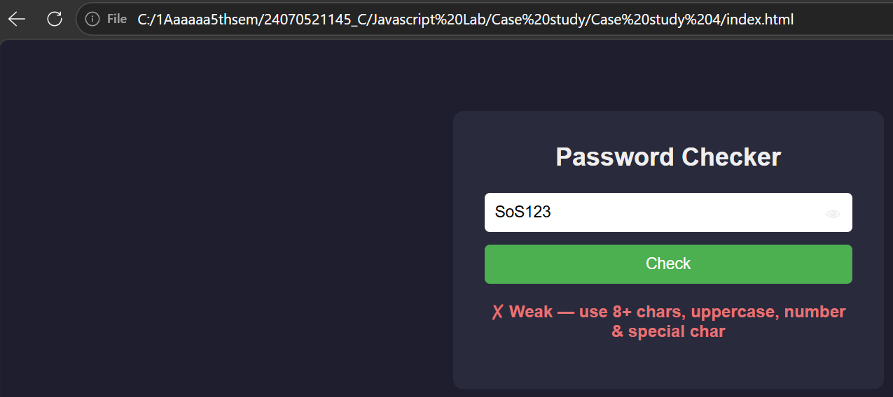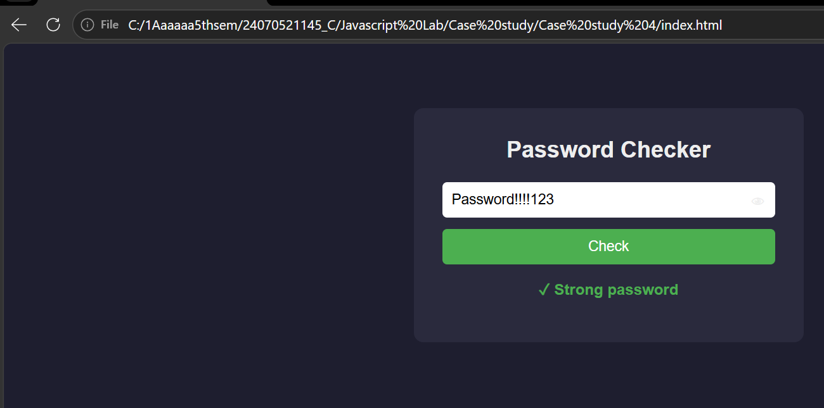

RESULT: Successfully developed and executed a Password Checker web application using HTML, CSS, and JavaScript. The program validates password strength, detects palindrome passwords, provides appropriate user feedback, and includes a show/hide password feature with error handling.

